Human Computer Interaction

Group Project

Group members:

Sam Carr

Ali Oztas

Ed Powell

Lewis Willoughby

# Project Aim

Streamlining and modernising the election voting system in the United Kingdom to allow the option to vote electronically via an online system.

**Core Features**

* Creating a domain that will allow users to cast a vote electronically
  + Create unique profile/ID based on National Insurance Number (NIN).
    - Linked to the identify of the user, similar to Student finance and the lifetime Customer Reference Number (CRN)
  + Synchronise this with the current election process: link NIN to paper vote
* Making a clear and user friendly interface that can allow voting to happen in a safe and unbiased fashion.
* Ensure the process is safe from exploitation and hacking
  + Encrypted processes and 2-step verification as standard
* Create a unified system of collecting and sharing votes
  + One universally accessible domain to broadcast votes live
  + Possibly real-time vote collation during the counting period

**Additional Features**

* Allowing for a mailing list to keep users updated as to when there is a vote in an unbiased manner
  + Possible link to candidates profiles
* Ability to provide a voting aid to help people to make a more informed choice
  + Fashioned after personality/psychological trait questionnaires.
* Possibly extending the voting period as the system would be online, and would not require real polling stations and staff

**Justification**

* Current system is out of date technologically and socially
  + Era of social media
* An online system will reduce the costs related to an election, reducing the numbers of polling stations and postal votes by giving people the option to vote online
* May increase voter turnout by making the process easier and less hassle
* Reducing the number of counting errors by having a number of votes in electronic format and not requiring hand counted votes

# Definition of the Problem to be Addressed

This project is there to address the problems with the system of voting in the United Kingdom. The problems with it can be seen as; the dwindling number of votes, the massive expense invoked by the calling of the vote, the accuracy of counting votes and a modernisation of the system that would reflect the lives of people in this era.

One of the major problems that the United Kingdom suffers with is a low voter turnout of nearly a 10% drop in the last 25 years. And the group that had the lowest turnout in the 2017 election was the 18 to 24 (House of Commons Research Papers, 2017) with only just over 50% turning out to vote making it imperative that the voting cohort is increased by making it easier than ever to vote. By making it easier to vote more people will vote. Currently postal and polling station votes are the only ways and they have problems with them, for instance if a person is away for the day they can’t vote in a polling station, and a postal vote could be lost or forgotten about but is also more importantly unsecure. A postal vote can be intercepted or tampered with by any number of persons along the chain, and for a general election it is imperative that the votes of the people are secure and unable to be corrupted.

The massive expense involved with calling a general election is also unnecessary and can easily be cut down on. The general election in 2017 was estimated to cost £170 million and the EU referendum in 2016 cost £142 million (TheGuardian, 2017). This is a massive spending in just two years, but this is nowhere near the true cost of voting in these two years because there are council elections, mayoral elections, by elections, Scottish parliament and welsh assembly and so many more votes that happen during that time, each incurring a cost. These costs being the cost of; sending letters to people, printing voting cards, hiring places to count votes and general expenses that would be incurred by the need for counters and paper. It would be unrealistic to think that the entire use of postal voting and polling stations would be abolished by the introduction of an online voting system, but their need would be reduced. the reduction in their use would mean that polling stations could be less in number and postal votes could be less. Also, the need to have massive halls where people count all the votes could be removed as they would be automatically counted by the online system. All in to this would save money.

The lack of modernisation of the system in the UK invites its own problems to the table as well, namely the inaccuracy of using humans to count votes and the rigidness of the system. At the moment, a person has a short window in which they can place their vote in and no opportunity to change their minds. These things don’t reflect the lifestyles of people these days in that they do not stick to a traditional day structure (E.G. 9-5 working hours) or they are more and more global either with work or out of work as people often have jobs that take them around the world but also holiday around the world as well, so it is reasonable to assume that they would be in a situation to miss the time in which they can vote.

# Review of Related Work

## Existing Voting Systems

In the United Kingdom a first passed the post system is implemented with regard to the way that votes are conducted. First past the post is where voters are given the chance to place one vote for one candidate on polling day and the one with the most votes is the one who becomes the MP for that constituency. For our system we will have to make it so that this kind of voting method is implemented as this is the one used by general elections in this country. With regard to the devolved regions they implement different methods e.g. Scottish local elections are cast by a single transferable vote. It would be unsure if such regions would follow so we should start with the main voting method. ("First Past the Post", 2017) ("Single Transferable Vote", 2017)

## Cybervoting

Cybervoting was a term first used in 1995 regarding French nuclear testing in the Pacific region. ("The Age, Melbourne", 1995) At that time, it was very limited because of the access to computers being so much more limited and peoples connectivity to the internet being much lower. The first major usage of cybervoting wasn’t until the Estonian national election in 2007 making them the first nation to use the internet to cast votes during a national election ("Estonia to hold first national Internet election - CNET News", 2017). Although the initial turnout was very low for the persons using the internet to vote by the 2014 election it had risen to 31.3% of votes were cast by that means. This astounding rise in its popularity shows that there is a demand for such a system to be available among people is used in Estonia mainly in rural areas where persons can’t reach a polling station easily ("Statistics - Internet Voting - Voting methods in Estonia - Estonian National Electoral Committee", 2017). When a person casts a vote online then it is encrypted to grant anonymity to the voter then tagged with the voter’s digital signature to ensure that it is the person registered to vote casting the vote, although the signature and the vote are separated to ensure anonymity. A person can change their vote by sending another one in during the voting period or on the polling day by going into a polling station.

To place a vote in Estonia a person must use their ID and their PIN code to log into the system. PIN codes can be requested from police stations, border guards board or respective bank offices. A person going to vote must follow the process of entering their Id card into a card reader in their computer then they download or run the voter application. They identify themselves with their PIN code to gain access to their account. They are then given a choice of candidates to choose from and once this is done they confirm it by performing a digital signature. They are notified if their vote has been accepted. This is the normal way in which votes are cast in their system, but it is possible to have variants of this to allow flexibility for people. For instance, some people have a digital ID rather than a physical which they use to log in, this form of ID doesn’t require any hardware to log in so is simpler. There are also mobile IDs as well, these are a SIM card that the ID and PIN codes linked to it and confirmation codes are sent to the phone to authorise the use of the account and to authorise the submission of votes. This mobile ID system is not in use yet. The notification of receiving the vote is important because it shows that all systems have worked correctly, and no malicious security breaches have happened. ("Internet Voting - Voting methods in Estonia - Estonian National Electoral Committee", 2017)

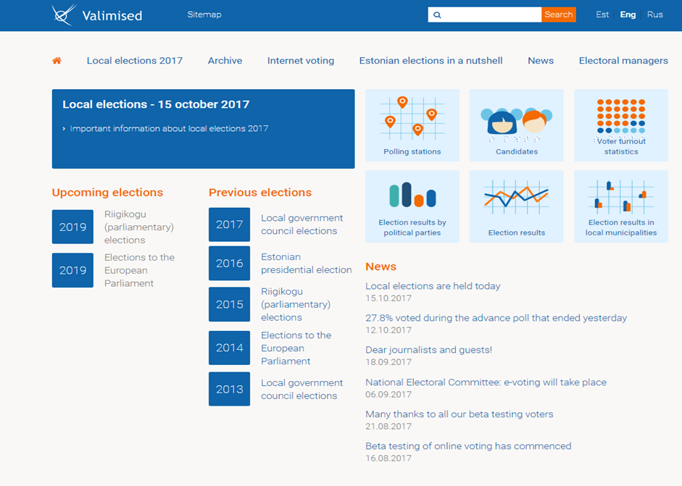

**Fig.1:** layout of the Estonian I-voting page- <http://www.valimised.ee/>

It is visible from this page that it offers a wide variety of information about the voting process upcoming votes and news about votes. The page has a clear and minimal appearance and is easy to read and to navigate. It explains the possible technical difficulties that a person may encounter during voting and how they should go about fixing these to allow an open opportunity to people even if they are having difficulties that are above their control. On the down side though it does not offer much assistance to the visually impaired and does not have a voice output or the option of larger text or different colours, but does offer different languages to cater to its citizens.

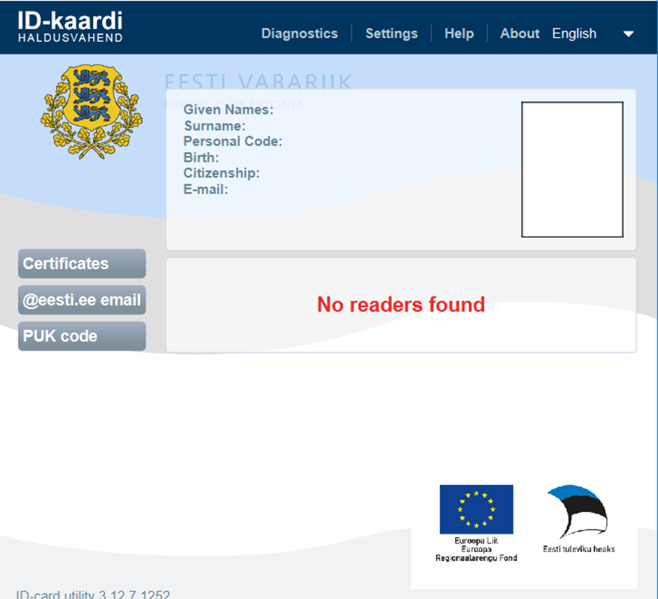

**Fig.2:** Layout of the application for identification downloaded from <http://installer.id.ee/>

This is the login page to where the votes can be cast. Is has a very clear layout and professional appearance making people sure that what they are accessing is what it claims to be. the use of a multi-platform ID service makes it very effective accessibility wise.  the requiring of a ID and a PIN insures that the page is very secure especially with the use of a physical ID as it would require a person to steal their ID as well as know their PIN which is a very low risk.

I-voting is used in Canada for some of the votes within city councils that approve the use of internet voting but not in federal or provincial elections. It was trialled in Finland in 2008 for a number of small elections but due to a usability fault the votes cast using I-voting were not counted and so had to be rerun.

## Problems with I-Voting

The main issues with the proposal of a I-voting (internet voting) system to people is the security of it. The ability of the system to allow only the person registered to vote once and under their own name, but also allow that person anonymity so that they can cast an unpressured vote. It is essential that only the voter can cast a single vote and for this it is usual to use an identification service like the National Insurance Number in the Register to Vote ("Register to vote - GOV.UK", 2017) system. which is a governmental controlled identification number personal to everyone of voting age. On the other hand, thought, it is important that a person’s profile is not linked to the vote they case for the reason of allowing a person to be anonymous when they cast their vote and not feel pressure of any kind because who they voted for could be known by someone. A system must strike a balance between registering a person’s vote and allowing them anonymity in their vote.  The site itself must be un biased and must hold no political agender, whether this be through its content its lay out and is colour scheme. This is of the upmost importance so that a person is truly free to make a decision without being illegally swayed to one direction or another. Finally, it must be accessible to all persons irrespective of their physical or mental impairments and it must allow all persons an equal opportunity to vote. A vote can’t exclude any person based on their attributes as this would be unfair so things like larger text, a simple layout and voice output must be available uniformly. ("Introducing E-Voting - Considerations —", 2017)

## Website Design:

The design of some example websites looking at the pros and cons of their structure and content and how this is applicable to our site.

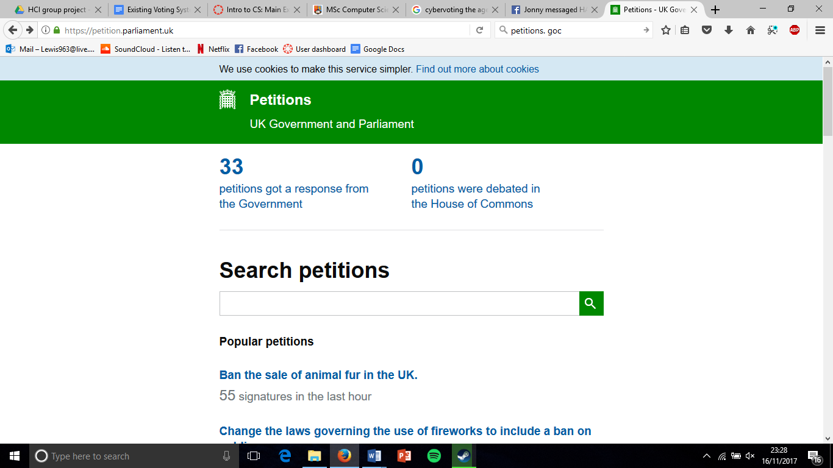

**Fig.3:** <https://petition.parliament.uk/>

This is the petition's website where citizens propose matters of concern to the government and if the achieve enough attention they will be answered. In design it is plain with little colour and large bold text spaced out along the centre of the page. With a white background and contrasting colours for the text making it easy to read and the positioning of the main feature, the search bar, in the centre of the page to allow easy notice, as this is the most important feature of the page. It is very minimalist, only having the important information that is required on the page and is well structured with the text aligned down the centre in rows to allow as easy navigation as possible.

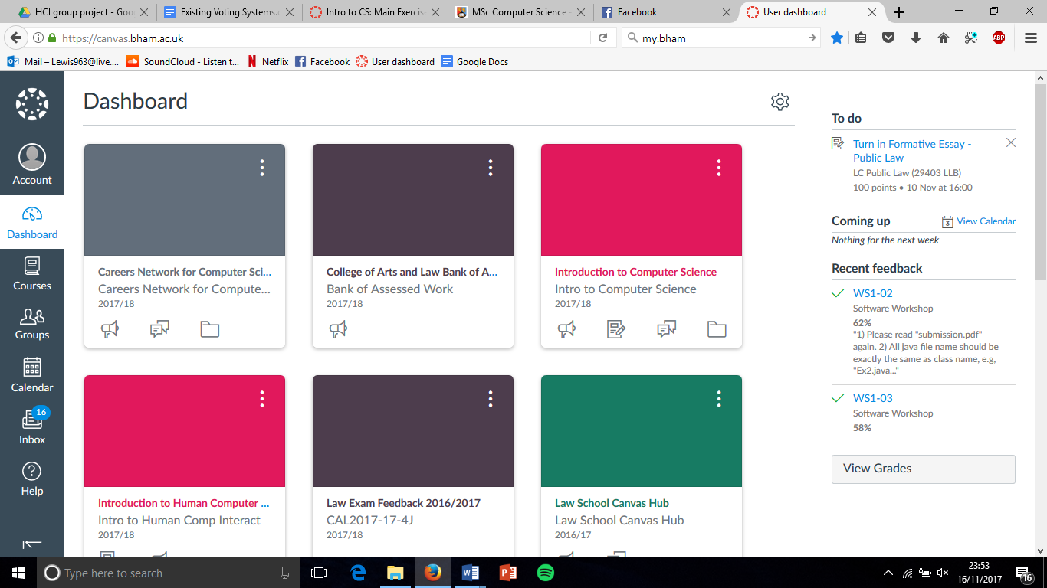

**Fig.4:** <https://canvas.bham.ac.uk/>

Canvas is a webpage for students and academic staff to access learning materials and upload assignments and convey information about their course. It is a plain design with few images and only a sparse use of colour and the colours used are keeping within a colour scheme. It has a simple page structure with a menu bar to the side and a sack bar to the other and then content filling the centre. The minimalist design makes the page very simple and helps with the ease of use and clarity, but the text used is small and my course difficulties for some people. Although it can be difficult to navigate through some of the pages as they are embedded within other pages. For a voting system it would way more streamlined as there is no need for the same level of content some many of the features are not applicable.



**Fig.5:** <https://www.reddit.com/>

Reddit is a website that presents user created content in a forum format where people can post their opinions about others posts. Its design is yet again minimal with a white background and plain text with a small number of images. It has a simple rating option next to people’s content, so opinions can easily be shared. Each content link gives quite a lot of information, but this means the text is small and somewhat hard to read. It has a strong consistent structure throughout the site and advertisements displayed around. As a page is it something we would wish to avoid as it's setup is very distracting and would not highlight the parts of our design which we wish to be highlighted.

## Desirable Web Design Features

The features we should include into our design from the research conducted should be to try and keep the background simple and clear to allow the foreground content to be clear and visible. Text should be sufficiently large and should be of varying size and colour to denote a change in subject matter or importance to draw attention to the highest priority tasks. The structure should be constant and easily navigated. Graphics linked to the text to reinforce ideas and information should only be relevant. If this is completed it will be optimised as a functional voting website.

## Login Security

In the investigation into the methods of maintaining a secure login process for Student Finance, Lloyds Bank.

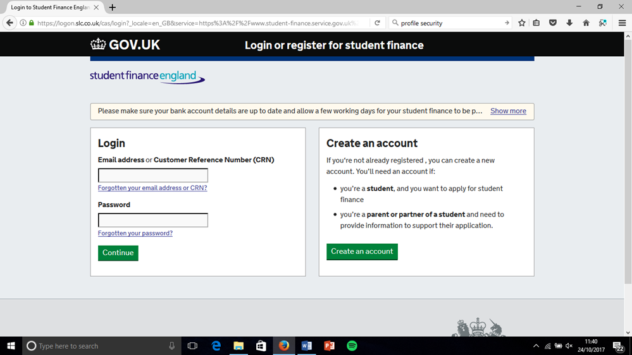

**Fig.6:** <https://logon.slc.co.uk/cas/login?_locale=en_GB&service=https%3A%2F%2Fwww.student-finance.service.gov.uk%2Fcustomer%2Fhome%2Fpages>

The login process for student finance consists of a two-stage login process. The first stage requires an email or customer reference number to identify the account and then a password. This gains access to the second stage which requires specific characters from an answer to a security question. Once these have been provided then access will be granted to the account. When trying to recover the account the person must provide personal information like their full name and date of birth and then have access to the email address that is linked with the account where the account recovery will be sent to.

The use of an email or customer reference number as account identification doesn’t pose much of a challenge to account security because it is for finding the account so that main requirements for this is that it must be unique and memorable so giving people a customer reference number but also offering the option for the linked email making it a fitting method. With regard to the password according to a password checking website a standard password of 8 characters, one capital letter and a number, would take two hours to crack by entering different combinations. By raising the length of the password it will exponentially get more complex and take longer to crack, but with added length it will affect the memorability of the password so a middle ground must be struck between the two variables where is I secure but also easy to remember. The issue of hard copies being made, and then lost or accessed, is also prevalent and should be another reason to not make them too difficult to remember. This leads onto another issue which has come up, the account recovery. The information required to recover the account is not information that is a challenge to acquire, by viewing a person's social media account then things like the name and date of birth can be found. Then the use of a third party system like email can put the system in jeopardy due to the varying levels of security which can make them the weak point of this system.

The site adds to its security the addition of a security question. It is possible for a person to choose their own security question from a list. In a security question it should be safe, stable, memorable, simple and have many possible answers. For instance, “what is your child’s nickname?” is not a good question because a large sect of people will not have children.  Today it is very simple for people to find personal information about others on social media like school, addresses, date of births and such things, with minimal difficulty. So a good example of a question would be “what was your favourite school teacher?” because this is information that will stay the same over your life, it is something that you would not post readily over the internet, it is simple and memorable and the number of possible answers are massive. the student finance website gives a prompt about what the information is which will reduce the security of the information as an attacker knows what information they are looking for. The entire information is not required in one log in but only three characters of it meaning that it is safe from shoulder surfing.

Other security risks identified are shoulder surfing simple trial and error or a search for hard copies. Within the student finance website and many other sites, they cover up password entries and memorable information and on the student finance they also don’t use the entire memorable information so will take more than one surf to be able to gain access making this a very low risk. The length of the password reduces the risk of trial and error and the use of a simpler password but the use of a memorable information. All in all the student finance website has a high level of security but it can take some pointers from other websites on how they can improve their security.

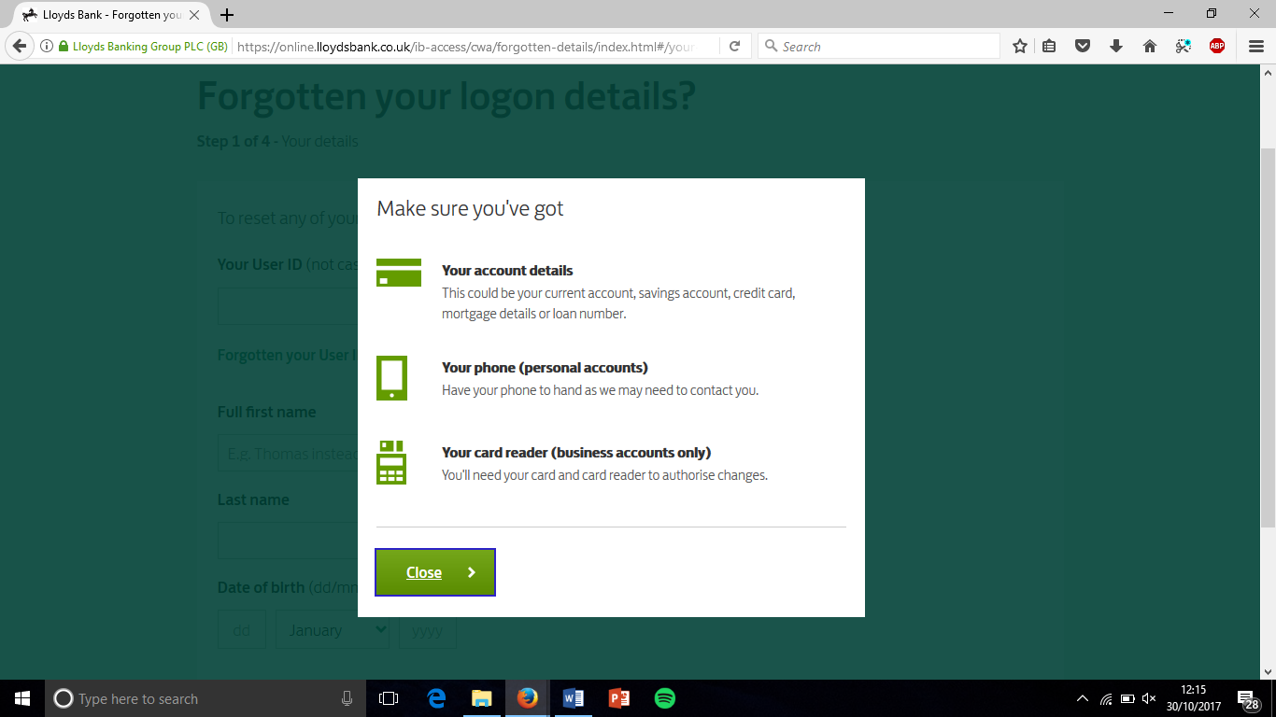

**Fig.7:** <https://online.lloydsbank.co.uk/personal/logon/login.jsp?WT.ac=TopLink/Navigation/Personal>

Lloyds online banking system has some features that have a higher security than that of student finance, namely their account recovery and their memorable information. On the Lloyds site it requires the account information and then access to the phone number that is linked to the account. This is much more secure than just requiring access to the email account because having access to this person’s phone number is a different system not on the internet and much harder to hack and an email account.

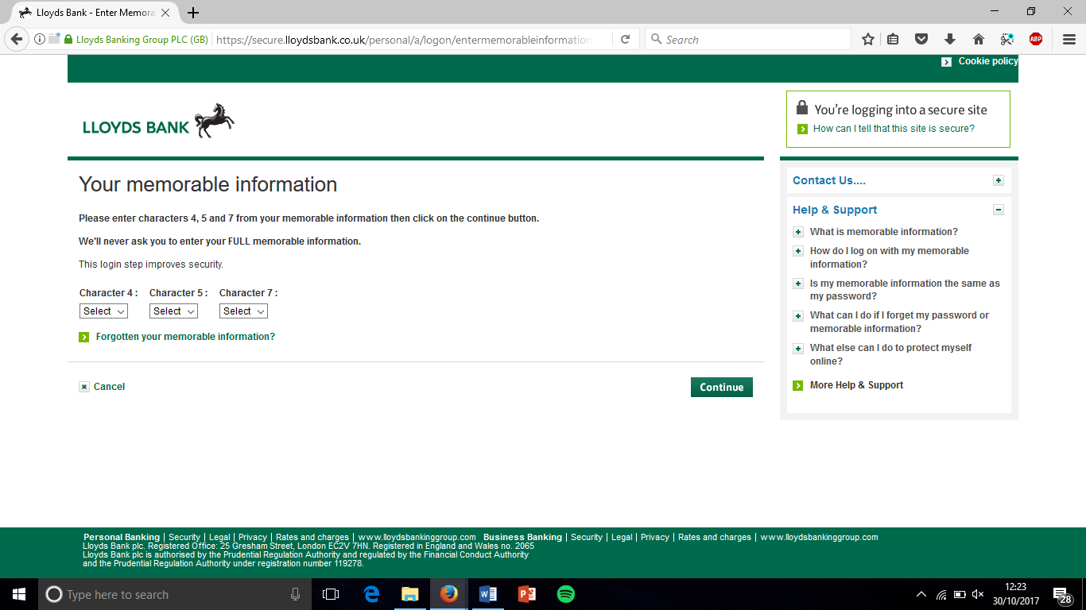

**Fig.8:** <https://online.lloydsbank.co.uk/personal/logon/login.jsp?WT.ac=TopLink/Navigation/Personal>

The difference between the student finance memorable information and Lloyds Bank is that student finance displays the question the memorable information answers making is easier to guess so I would be an idea to take this approach and make it as secure as possible.

## Features to Implement

Things to take from the student finance and Lloyds bank system is that there should be an ID like email or a system generated ID to make sure they are unique. A password should be more complex than 8 characters, one capital and one number, so that it not realistically going to be cracked but obviously not too long that it is not memorable. Having a memorable information which doesn’t prompt the question meaning it can’t be guessed. Using a system like mobile number provides a more secure recovery system than email so that should be used and is a third-party system that is accessible by the majority of people of voting age. I think by implementing such features it would mean that the system would be protected from attacks and still easy to access.

## Research into Existing Voting Opinions

1) Thinking of the ease of use of our voting system (namely postal voting and polling stations) on a scale from 1 being very difficult to use and 5 being easy to use how would you rate the voting system in the United Kingdom?

(place a cross in the box of your choice)

|  |  |  |  |  |
| --- | --- | --- | --- | --- |
| 1 |  |  |  | 5 |

2) still thinking about the ease of use; how important do you think it should be for the voting system to be easy to use and access, 1 being very important and 5 being  not important?

|  |  |  |  |  |
| --- | --- | --- | --- | --- |
| 1 |  |  |  | 5 |

3) with regard to the security of the vote; how secure do you think the voting is at the moment on a scale of 1 to 5, 1 being very secure?

|  |  |  |  |  |
| --- | --- | --- | --- | --- |
| 1 |  |  |  | 5 |

4) on a scale from secure at 1 and easy to access at 5; where in your opinion do you think the access to your profile should fall onto the scale for an online voting system?

|  |  |  |  |  |
| --- | --- | --- | --- | --- |
| 1 |  |  |  | 5 |

5) where on a scale from 1 to 5, where 1 is how clear and concise the webpage is and 5 is informative and information rich the webpage is; where on such a scale would you put an online voting system?

|  |  |  |  |  |
| --- | --- | --- | --- | --- |
| 1 |  |  |  | 5 |

6) by thinking about how much you would like each feature to be included by giving each of them a score of 1 to 5, 1 being should not be included and 5 being it is imperative to be included; what score would each of these possible functions get?

(place a number in the box provided) https://docs.google.com/drawings/d/sQME459IDVTeOOIp7M_yZ2A/image?w=97&h=21&rev=1&ac=1

A candidate profile with a brief message from each candidate to an election-

https://docs.google.com/drawings/d/sWnJ7DKRVjExjyGaAGHR5xQ/image?w=97&h=21&rev=1&ac=1

Reminders about upcoming elections by email or other specified means-

A voting aid that asks questions as to a person’s opinion on matters and then translates them into whether they are aligned with a particular party- https://docs.google.com/drawings/d/sIuGrYrqosuu9FRBxOfji0g/image?w=97&h=21&rev=1&ac=1

https://docs.google.com/drawings/d/s4LfB1-AdjZ8hl2AplS33MA/image?w=97&h=21&rev=1&ac=1

Having a longer period to vote in and the ability to change their vote until a deadline-

7) if the option to vote from home over the internet was available would this change whether you would vote or not? https://docs.google.com/drawings/d/sCnoV1zaz_H8mi-tLdSze1w/image?w=177&h=28&rev=22&ac=1https://docs.google.com/drawings/d/s_e4diUEK4wWOwsP2yN-8Lw/image?w=177&h=28&rev=15&ac=1

Survey Results

During the survey we asked 24 people the survey questions and collated their answers.

Q1)

|  |  |
| --- | --- |
| Answer | Frequency |
| 1 | 2 |
| 2 | 7 |
| 3 | 9 |
| 4 | 5 |
| 5 | 1 |

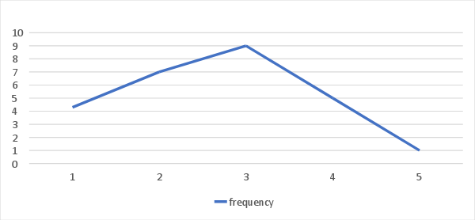

The correlation shows that the majority of the votes were towards the end of the spectrum which denotes that the people opinion on the voting system at present is difficult to use and that they would wish to change it. Although there was a present amount that were happy with it or that were indifferent.

Q2)

|  |  |
| --- | --- |
| Answer | Frequency |
| 1 | 12 |
| 2 | 9 |
| 3 | 4 |
| 4 | 0 |
| 5 | 0 |

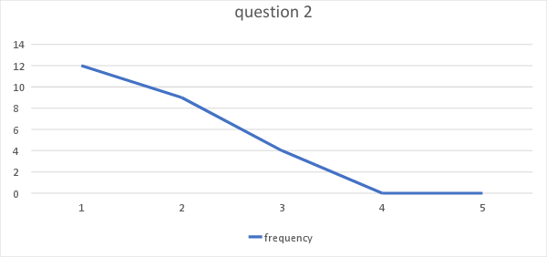

Results show that people value the ease of use of the system is of paramount importance with no people having the opinion of it being unimportant. This means we should take care to create a domain that is very user friendly.

Q3)

|  |  |
| --- | --- |
| Answer | Frequency |
| 1 | 11 |
| 2 | 9 |
| 3 | 3 |
| 4 | 1 |
| 5 | 0 |

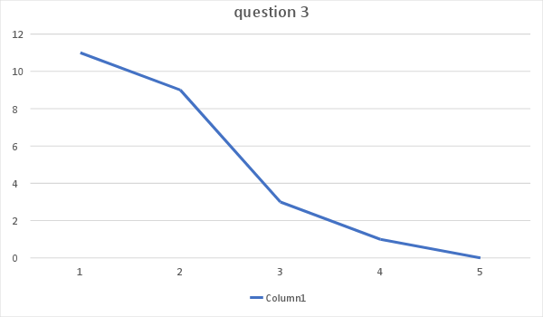

The survey also shows that people want a system to be secure and safe almost to the same extent as the need for it to be easy to use. So it must be considered how a website can be easy to use and access but also secure. This is a clear need from the audience.

Q4)

|  |  |
| --- | --- |
| Answer | Frequency |
| 1 | 3 |
| 2 | 6 |
| 3 | 6 |
| 4 | 7 |
| 5 | 2 |

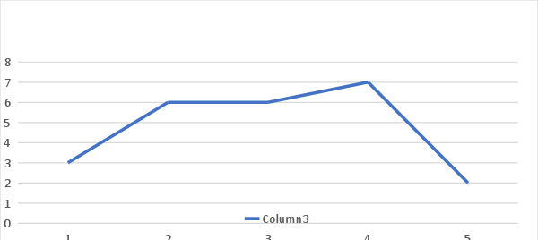

There is no clear answer really from this which infers that generally people think that security and ease of use are equally important

Q5)

|  |  |
| --- | --- |
| Answer | Frequency |
| 1 | 5 |
| 2 | 7 |
| 3 | 6 |
| 4 | 4 |
| 5 | 2 |

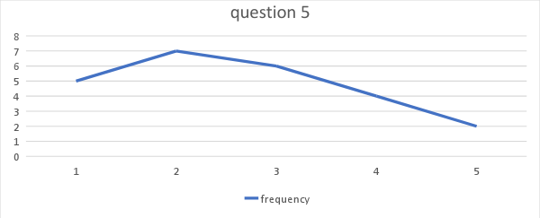

This shows that our website should not be too cluttered and should keep itself clear from being too overwhelming to voters.

Q6)

|  |  |
| --- | --- |
| Answer | Frequency |
| Candidate profile | 14 |
| Reminders | 16 |
| Voting aid | 8 |
| Voting period and ability to change vote | 20 |

From this it can be seen that people think of the most important extra features that our website should have are the ability to change a vote until the deadline then the reminders and then candidate profiles. We should use this guidance to decide what we should add to the website and what is appropriate.

Q7)

|  |  |
| --- | --- |
| Answer | Frequency |
| yes | 15 |
| no | 9 |

The response to this shows that people will be more likely to vote if they are given the option to vote online, this is incentive enough to make this domain.

# User Requirement Personas

## Persona Number 1

Name: Tom Griffin

Age: 22

Single

Graduate

Lives with another graduate

**Description**

Tom Griffin is a graduate from the University of Birmingham, and lives in an apartment in Birmingham, working full time. He has taken an interest in politics whilst being at university, but due to a general election not taking place, has not voted. He did not vote in the election before university as at that time he had no interest in politics.

Due to being a student for the last several years, Tom has moved fairly frequently, and has not had a permanent address. This is an issue in Tom’s eyes as he believes the process to change your registered address for the postal vote or regular vote is a lengthy process.

He keeps up to date with technology and has a new laptop and smart phone. All his correspondence is done via email. However, he does not own a television and doesn’t watch any news channels. Therefore, he struggles to find unbiased information about the parties and is unclear which parties align with his views and who to vote for.

**Main Points**

* Tom takes an interest in politics however has never voted
* He would be interested in voting in the next election
* However due to a busy schedule doesn’t think he’d have time to vote in person
* Has moved house frequently whilst at university
* Doesn’t want the hassle of setting up a postal vote

**Goals**

* To be able to vote online
* To not have to set up a postal vote and post the actual vote
* To not have to take time out of his work to vote in person
* To keep up to date with the election as it is happening

**Pain Points**

* Tom is generally unsure about the whole voting process
* He uses public transport, so getting to the voting venue would be hassle

**Scenarios**

* Tom has been working a lot and generally has fallen out of touch with the election due to not being able to watch news channels when he’s home at night. Because of this his desire to vote has fallen dramatically.
* It’s election day and Tom is working late until 10pm. He has had free time at work, but hasn’t been able to leave to vote as the public transport is fairly infrequently. Because of this he missed his chance to vote.
* Tom is feeling particularly lazy after a long week of studying and partying. He would prefer not to have to walk all the way to the polling station.

## Persona Number 2

Name: John Reynolds

Age: 45

Occupation: Senior Stock Broker

**Main points**

* Has a busy life
* Lives in a large, congested city
* Is used to using and learning new technology
* Would like the process of voting to be simple
* Keeps informed about politics and has a good idea of who to vote for
* Is used to voting in person
* Has doubts about the security of online voting systems

**Goals**

* To vote with minimal disruption to his busy schedule
* To set up and learn how to use a new system if it will be more convenient
* To vote using a simple to use system
* To ensure that his choice of vote is in his best interests

**Narrative**

John is a 45 year old male who works as a Senior Stock Broker for a large financial firm that he has been at for over 10 years. He has a a very hectic schedule and often works with overtime from 8am to 7pm and six days a week. He is a regular voter in not just the general but also in the local elections. He likes to keep himself well informed about politics so as to vote for candidates which align with his interests, such as keeping taxes for large earners low.

John owns a car but due to congestion, uses public transport to get to work. He has a developed routine of going to vote in person at his local polling station, which is 1.5 miles away from his home, and not on the same route as his work. He generally has work on election day so after work he arrives home, eats and then drives to go vote. All in all his trip takes 25 minutes. He would prefer if it didn’t take so much time and effort as he is usually tired from working that day or the day before. However the John doesn’t entirely trust the idea of using an online system as he has heard stories of foreign elections being hacked and manipulated. From his job he is used to learning about and using new computer systems and would be happy to use an online voting system if he can be convinced it is safe as this would be a more convenient way of voting for him. He would also like if the system is easy and simple to set up, learn and use.

On UK election day polls open from 7am to 10pm. John may be working for none, some or even all of that time.

**Pain points**

* Doesn’t want extra complication due to setting up and learning a new system
* Doesn’t want to spend unnecessary time voting
* Would prefer not to have to drive to the polling station due to congestion
* Is unsure of the safety of online voting systems

**Scenarios**

* John has just finished a busy day at work, from 7am till 9pm. He arrives home at 9.30pm and has no time to eat if he is to make it to the polling station before it closes at 10pm. He must get in his car as soon as he gets home. When he arrives at the polling station there is a queue. Thankfully he joins the queue before 10am and so is allowed to vote, but the close call worries him. He only arrives home at 10.45pm and must go to sleep soon.
* Election day occurs on Johns day off. He has all day to vote, however his car is currently broken down and public transport does not go any closer to the station. John is tired from working the day before but will have to walk 1.5 miles if he is to vote.
* John has an important portfolio to work on and works all day from 7am to 10pm. He has no time to reach the polling station to vote. He is worried his preferred candidate will be elected and he is unable to exercise his democratic right without making career sacrifices.

## Persona Number 3

Name: Amy Adams

Age: 63

Occupation: Retired  
2 Children  
3 Grandchildren  
Medium Level of Computer Expertise

**Main Points**

* Amy lives with her husband.
* She is well informed about politics.
* Amy likes talking to people about news and politics.
* She does not trust people other than her friends.
* Amy is hidebound and does not trust online systems.
* She does not trust online systems.

**Goals**

* To keep the system easy to use.
* To have tests to show public that the system is safe and anonymous.
* To ensure that there are people who will help the low/medium level users.

**Narrative**

Amy is a 63-year-old woman who has been living with her husband since they married. She goes for a walk every day and likes interacting with people. She watches the news and reads the newspapers every day. She discusses the politics with her husband and with her friends. She is not a close-minded person in general, but she does not trust online systems such as banking and shopping. Her children showed her how to use the online system of the bank which has her account for 30 years. She is used to that system because it is easy to use, and she can get help if she ever has problems.

She believes that electoral fraud tends to happen since people fill and count the ballot papers. She does not trust online systems either, but she is more likely to trust an unbiased system with neutral test results than to trust people that can fill the unused ballot papers.

She likes the existing system because she can keep her anonymity and she knows that her vote will matter when she fills the ballot paper and puts it in the box.

If there will be an online system, Amy wants to know that she can only vote once, and no other person can change the vote but her with vote being anonymous. She wants to be able to call someone if she struggles with the system.

**Pain Points**

* Amy does not trust online systems.
* She wants to see that her vote is a final part of the result and it is anonymous.
* She wants to know that only she can change her vote.

**Scenarios**

* Amy just saw a news about an election abroad has been resulted but when she checks the social media, she sees videos of people filling multiple ballot papers and using the papers. She doubts that if her vote will ever matter.
* Amy and her husband bought a ticket to go on a vacation but just before the election day occurs they realize that their ticket is early in the morning. They do not know what to do.
* Amy is not very accustomed to computers and even less used to using online voting systems. The idea of the whole process confuses and worries her. She might be more willing to try it if it were easily accessible and simple for her

# First Generation Prototypes

## Prototype 1

### Rational

This prototype was produced to highlight the small things that can be done wrong in the production of our website. By thinking of the potential things, we can do wrong but still produce a website that is functional and completes its specification then it allows us to have a clearer idea of how to avoid these errors. This is a good tool for avoiding such errors by thinking about them purposefully, so they are clearly noticeable when it comes to creating the final design.

### Description

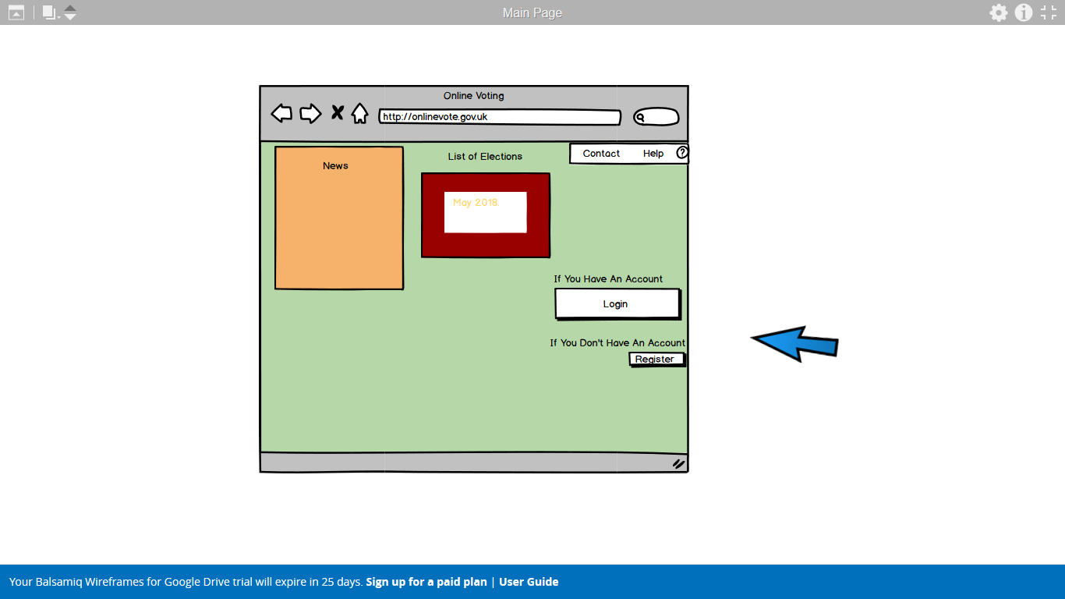

**Home Page**

The initial screen when accessing the webpage. It will be populated with a news feed, list of upcoming elections and has links to the login and register pages.

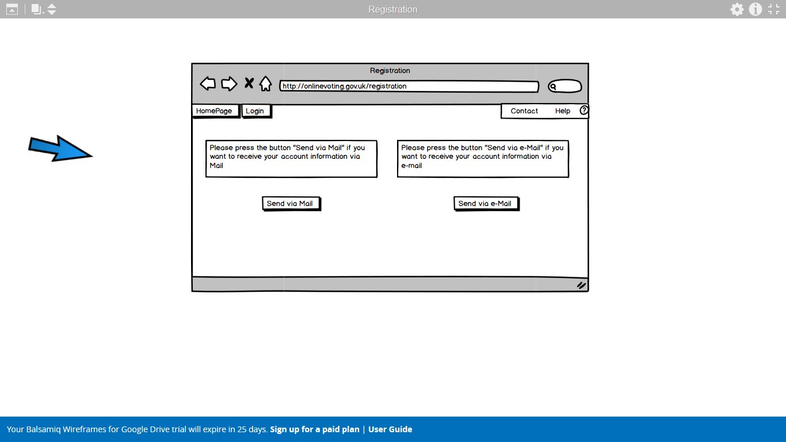

**Registration preferred method page**

Page gives the option to choose between methods of contact, giving a helpful description for both.

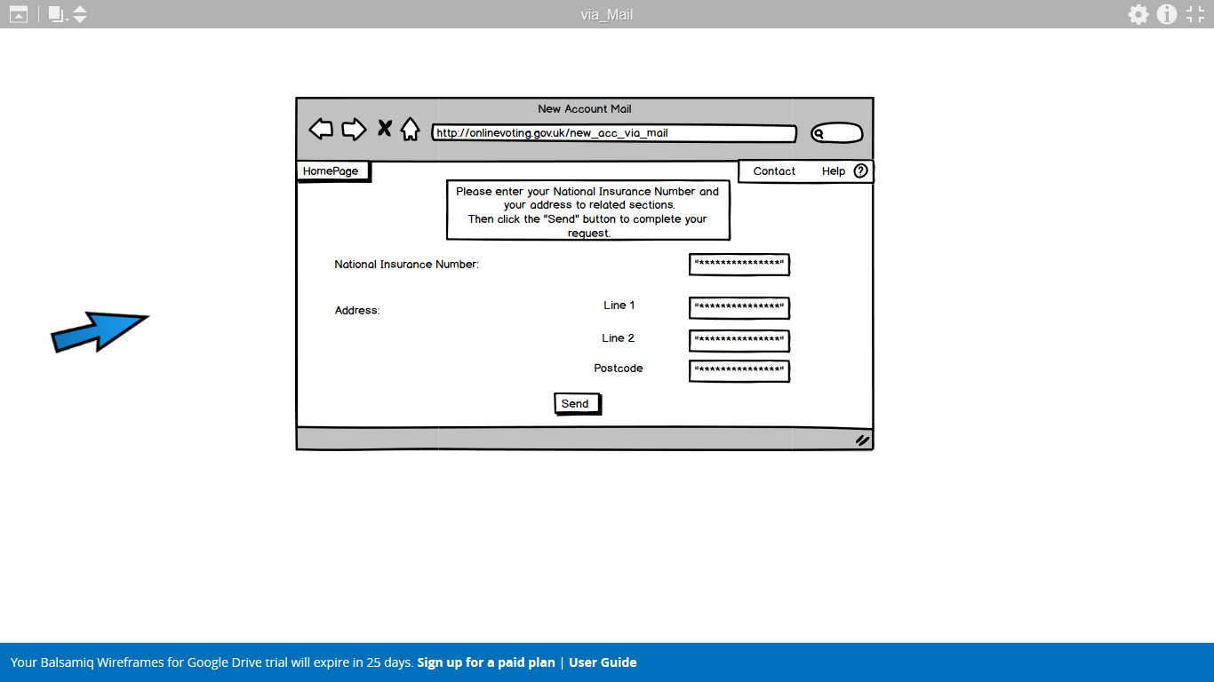

**Registration via mail**

Page that allow the user to input their information, so it can be processed and an account can be made.

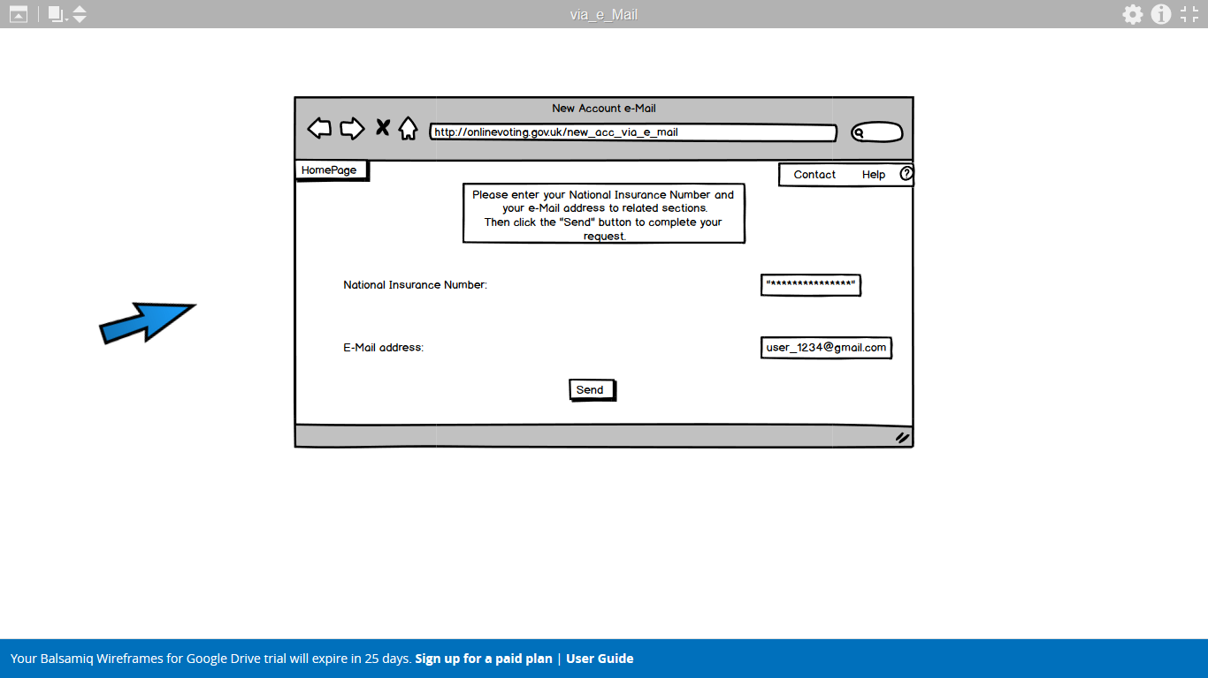

**Registration via email**

A similar page to the above but for registration via email instead of postal mail.

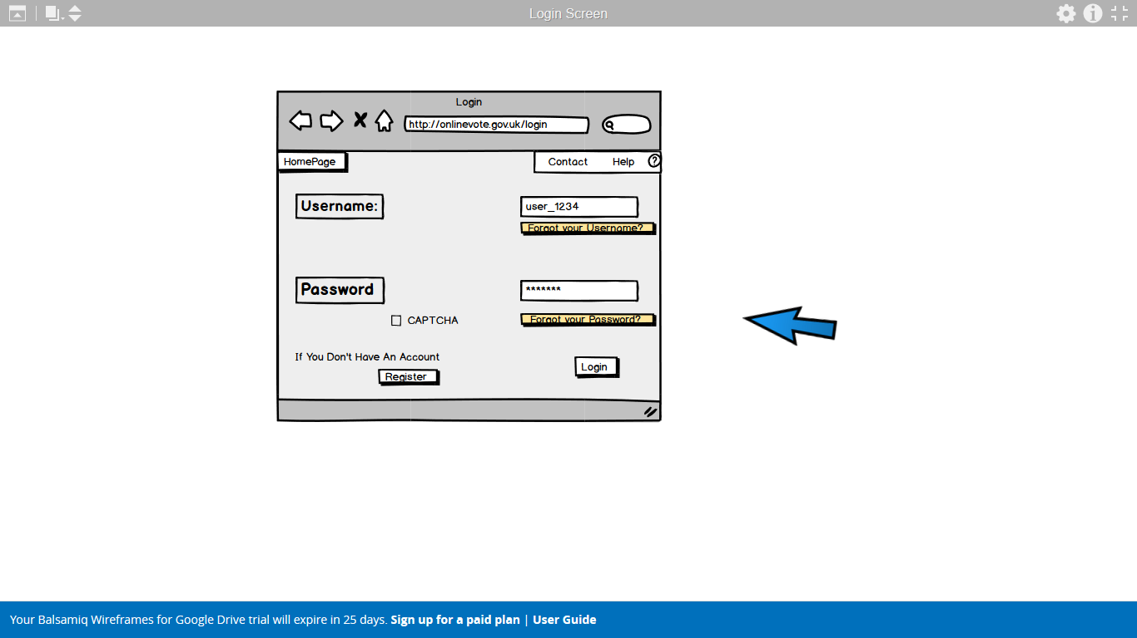

**Login page**

Page for entering account information with links to the forgotten information pages and a CAPTCHA tag to check for authentication of the person.

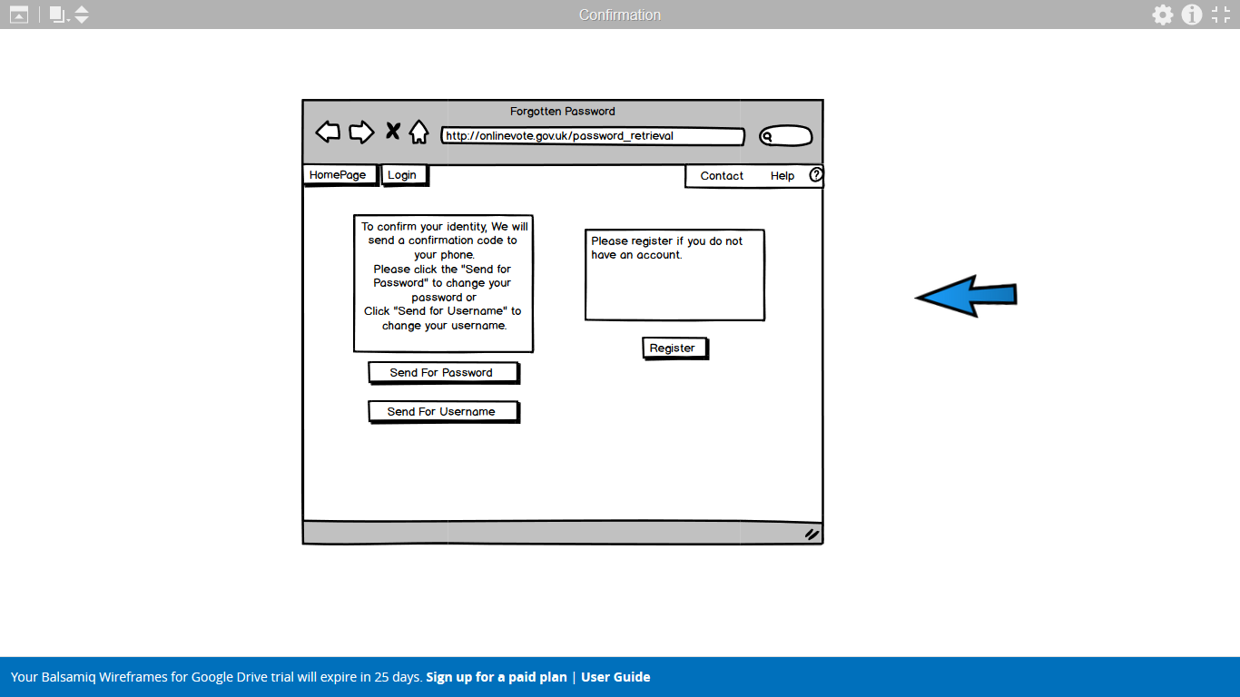

**Forgotten information page**

A page to recover lost information about an account. It has links for a lost password or username and one to register an account.

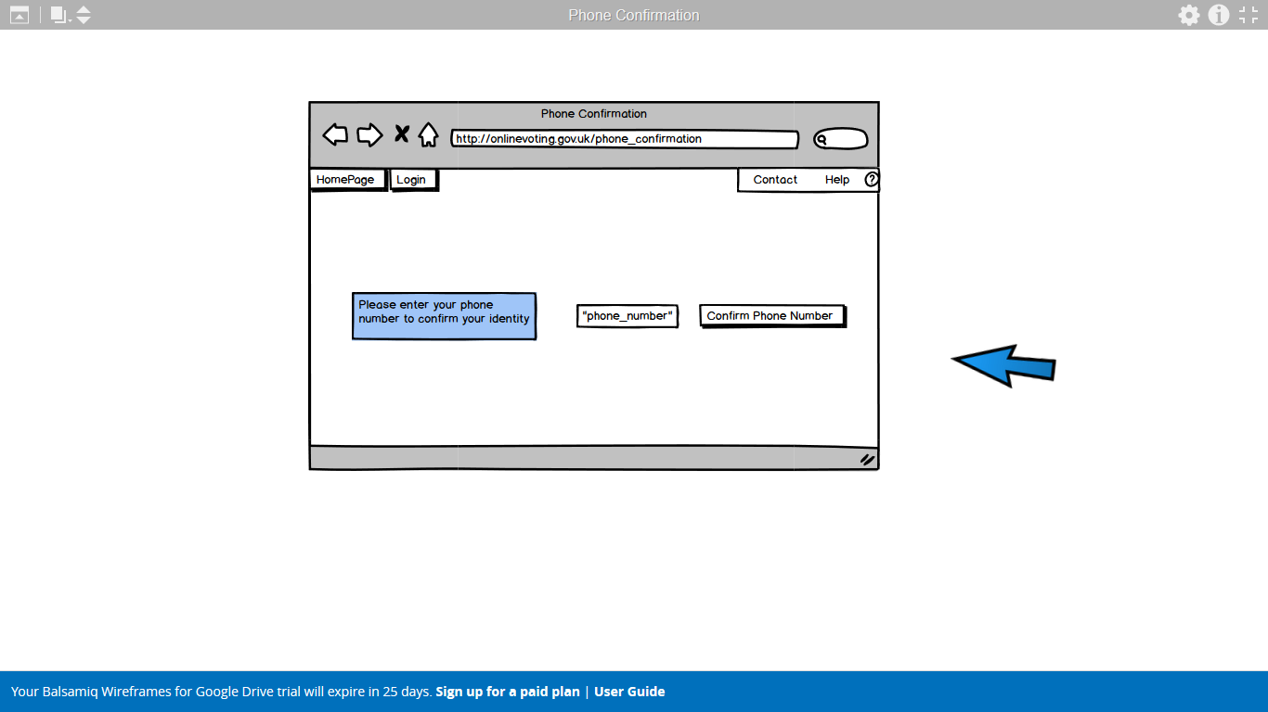

**Phone confirmation for lost information page**

Requires the phone number linked with the account so that an authorisation code can be sent

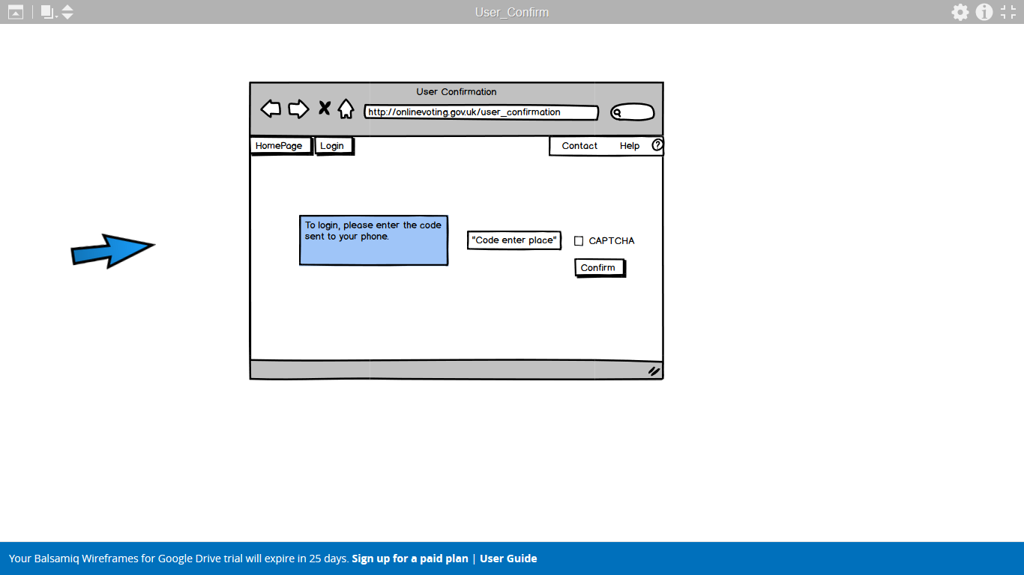

**User Phone confirmation page**

The user enters the code sent to their phone and satisfies the CAPTCHA to authorise access to the account as part of the login process.

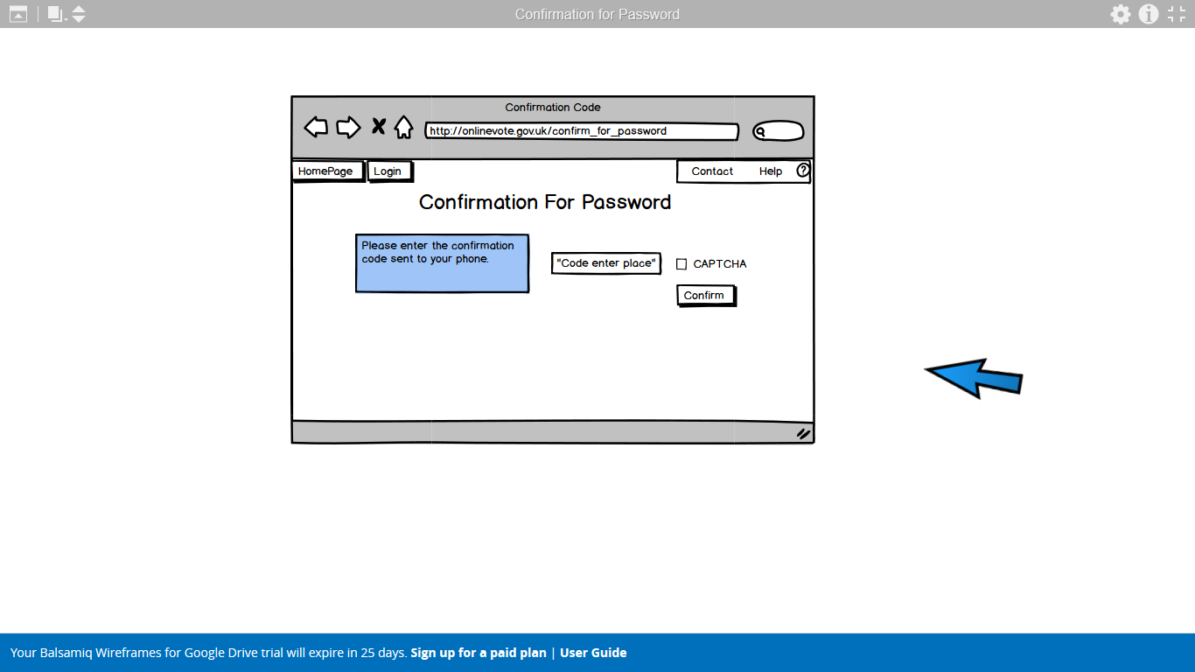

**Password phone confirmation page**

A similar page to the above for the phone confirmation but this time confirming that the user has the permission to change the password.

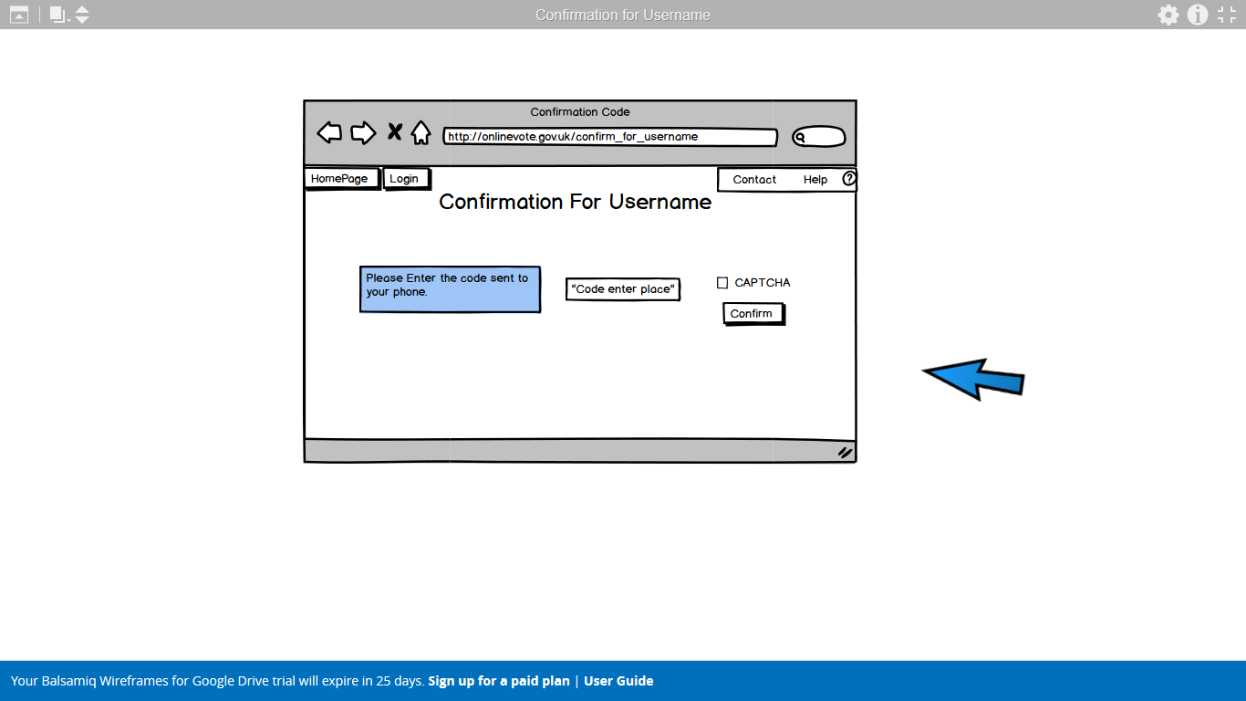

**Username phone confirmation page**

A similar page for the changing of the username of a user by phone confirmation.

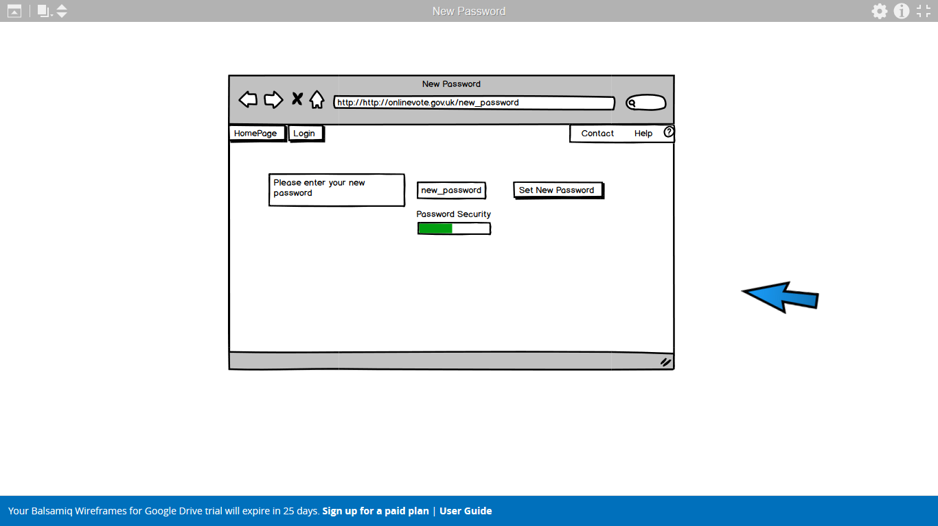

**Password setting page**

Page for the setting of a new password. It has a strength checker visual for the password to insure it is adequate.

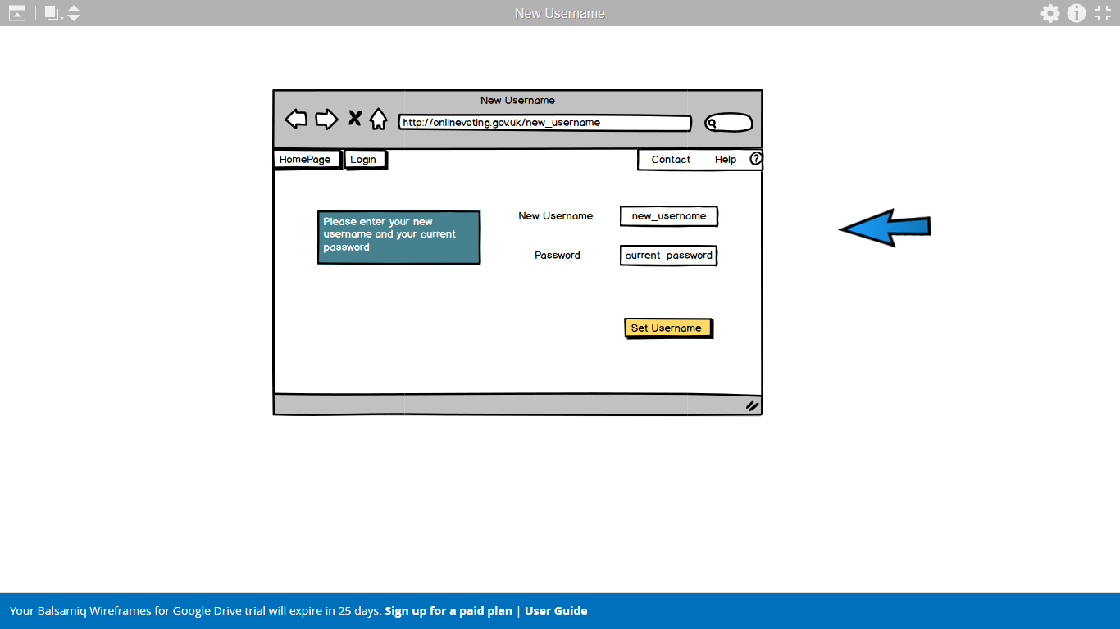

**Username setting page**

Page for setting of a new username with helpful colours to aid the navigation of the page.

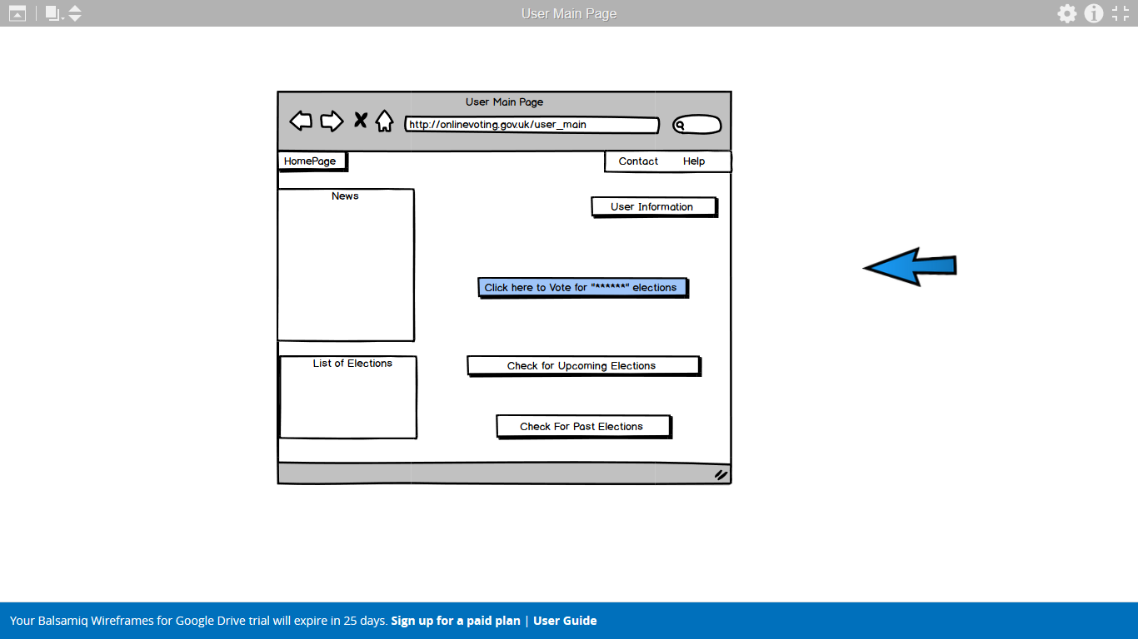

**User main page**

The users main page where a news feed and election list are displayed along with links to the voting, upcoming vote and the past election pages as well as the user information page.

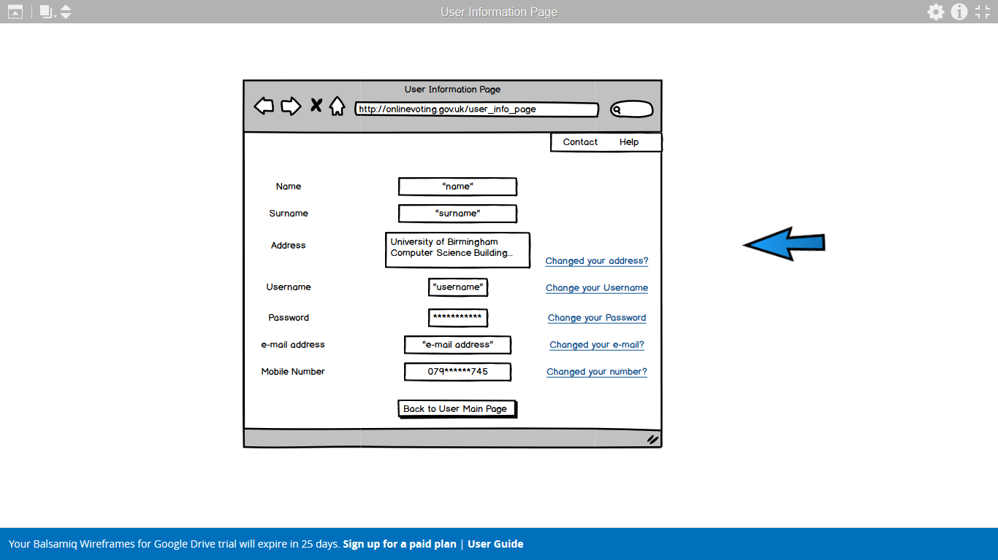

**User information page**

Page showing the users information with links to changing any of it and a return button.

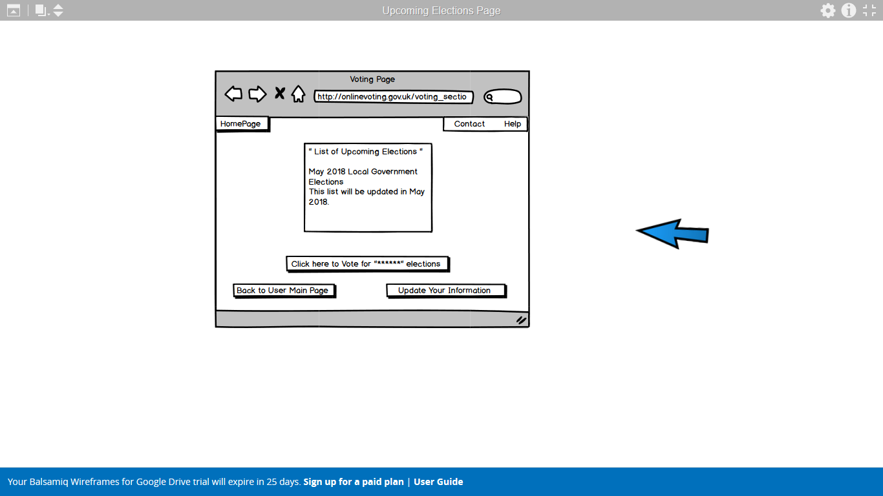

**Voting page**

Page where a person can choose to vote for a particular election or return to the main page or update their information.

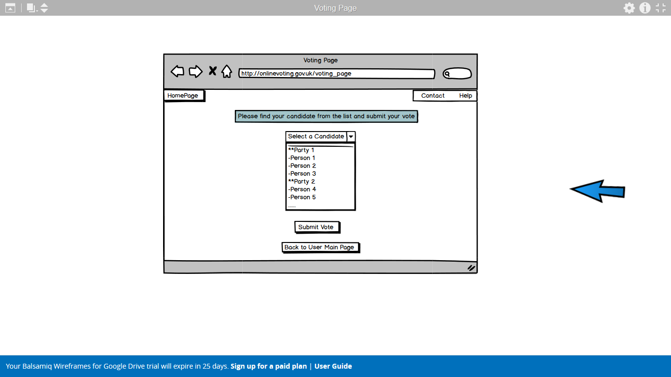

**Vote casting page**

Page for the casting of a vote. The user selects the candidate from the drop-down menu and then submits the vote or chooses to go back.

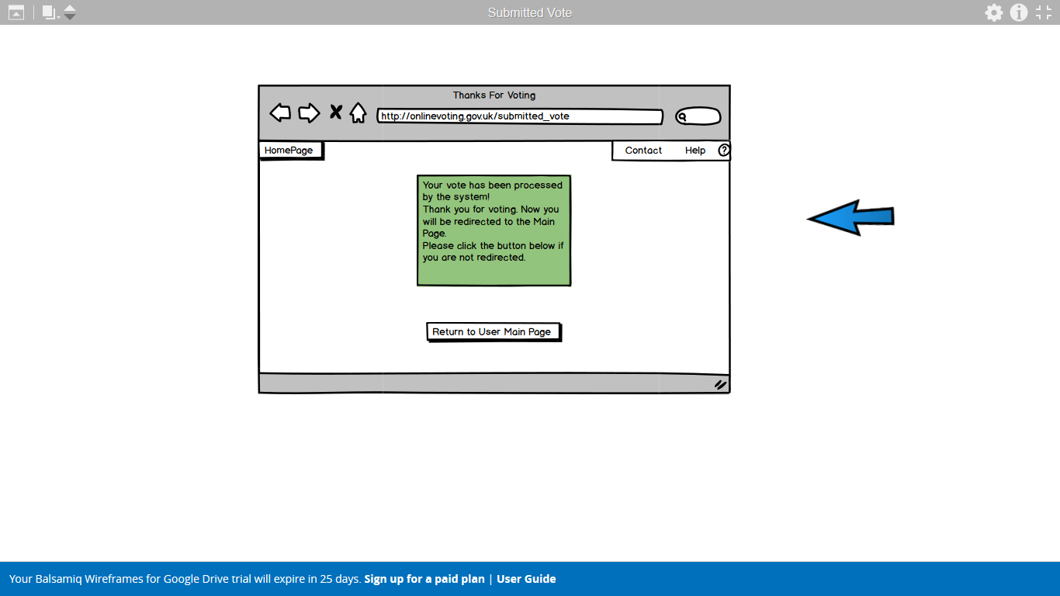

**Submitted vote page**

A page for the acknowledgement for the casting of a vote.

### Evaluation

**Positive Points**

* System helps the user if they forget their information.
* Layout is simple, and instructions are clear.
* Phone number is checked if it is the user’s telephone number.
* With confirmations only, the account holder can login to his/her account.
* User can change the information on the system if necessary.
* User can see the past and upcoming elections with the news related to them.

**Negative Points**

* For a formal system, main page has too much colouring which affects the user’s view on the system.
* Too many redirections to login.
* Representing candidates in a combo box is a bad way to view. User may not be able to find the candidate.
* Besides unnecessary colouring there is no certain pattern to colouring which makes the website look unorganized.

This prototype is made to represent the little bad details that can be in a functional system. System has clear instructions that are telling the user what they need to do. It is secure with the confirmation and CAPTCHA usage. In this prototype, there are no registrations. Username and password will be sent to user on e-mail or mail according to user’s demand. An online registration system can be implemented which will give the users their own username and password according to their National Insurance Number. It must be checked properly, and it must be confirmed by the user in the process that it is the user creating the account for privacy measures and to avoid spam. If the users forget their username or password, they can retrieve their information from the system with the confirmation process. Users can see the news on their user page or in the general website which will give them information about elections and important news. Upcoming elections section will help to keep the users notified and they can look for the past election results. Users can change their own information in system except their names from username information page. System allows the users to return to their user pages or the main page in most of the parts.

As it has been mentioned, this prototype is organized poorly with the usage of unnecessary and wrong colouring. Moreover, colouring can influence the voter’s trust towards the system. To view the candidates in voting page, combo box is a poor way to view for the reason being that separation by parties cannot be displayed properly and users do not want to waste time looking for a candidate.

Finally, this prototype helps the user in every section, but it can be improved with the little fixes mentioned. Further changes and fixes to the system will be given and addressed in the final prototype.

## Prototype 2

### Rational

The first prototype was designed to incorporate a simple design, an easy accessibility and an uncluttered space. The idea behind these things is to make it as simple and functional as possible to maximise the usability. One of the key features that the site must contain is a very high usability that is open to all manner of people to use. To achieve this during the making of this it was kept in mind to only include the bare minimum content and not to add information that wasn’t essential to aiding the user in their navigation of the site. This was done by keeping clear and basic colours, minimizing text to the bare minimum and what text is there is for the aid of navigation.

### Description

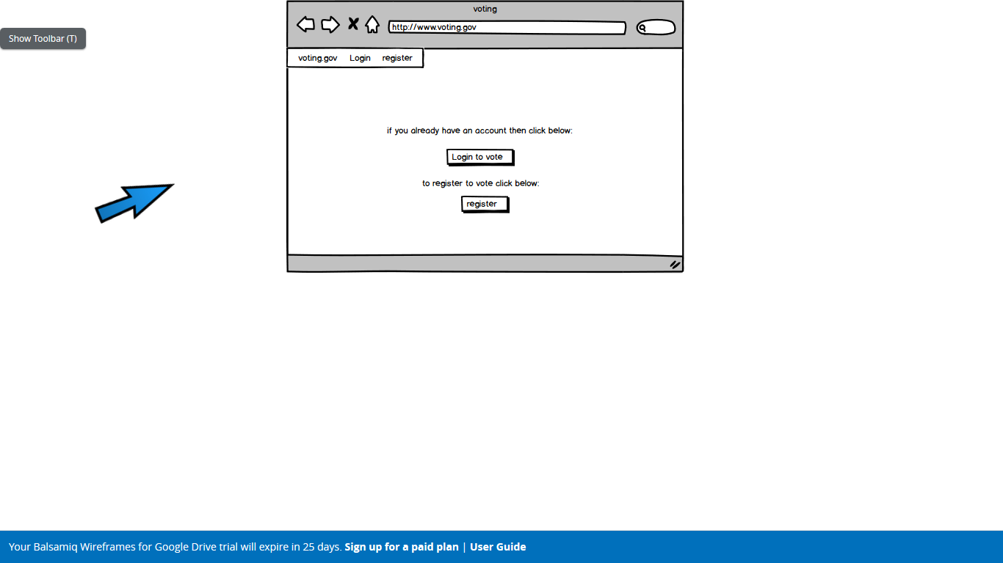

**Home page**

This is the first page that would be displayed when the site is accessed. It gives two buttons that can be pressed, one leading to the login page and the other to the register to vote page, with additional navigation provided by the menu at the top left of the page.

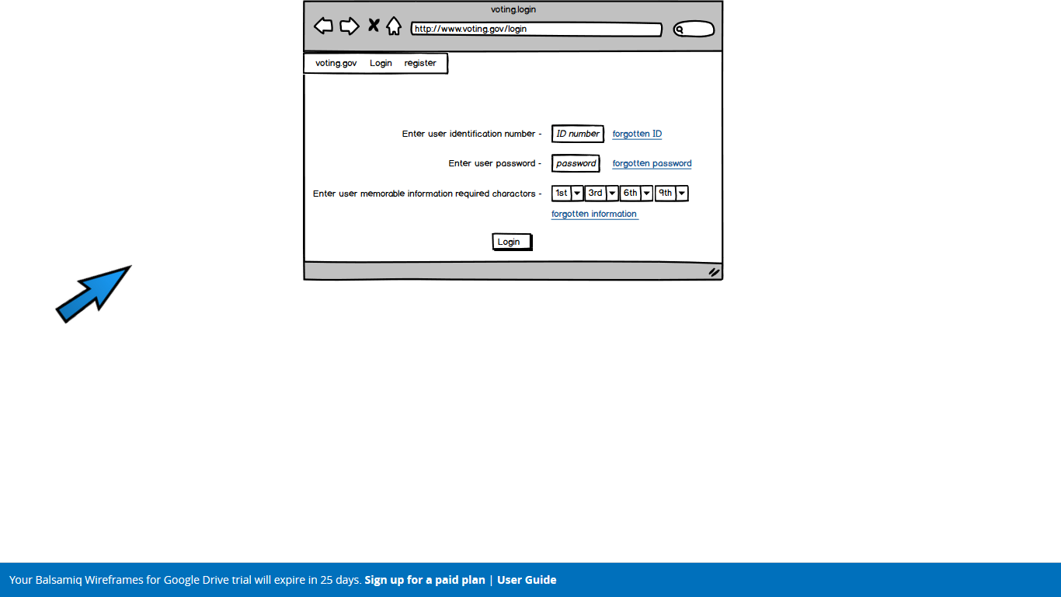

**Log in to vote page**

This page has text boxes for the ID number and password to be entered. The password will be covered as it is entered into the box. The characters of the memorable information must be entered in character numbers as requested and links to account recovery pages are provided.

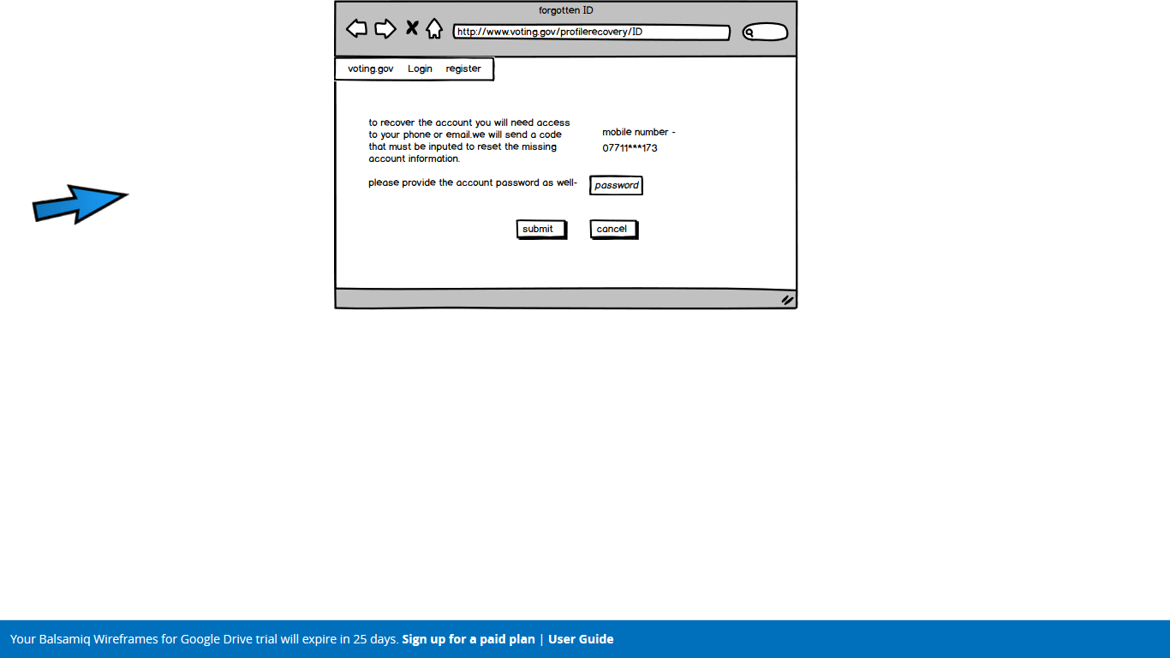

**Forgotten ID details page**

The page explains the method of account recovery and provides a space to input the password to allow a code to be sent and then a submit or cancel button.

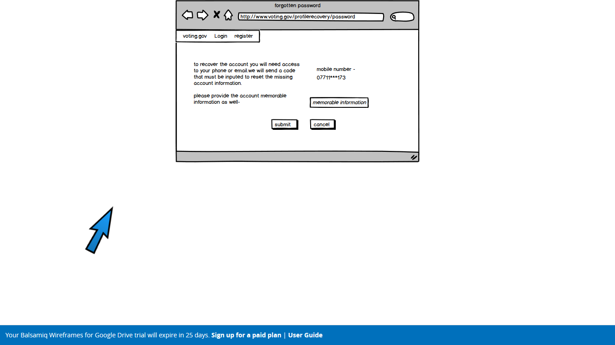

**Forgotten password page**

A page corresponding to the above but for a forgotten password rather than ID



**Forgotten memorable information page**

The same for memorable information.

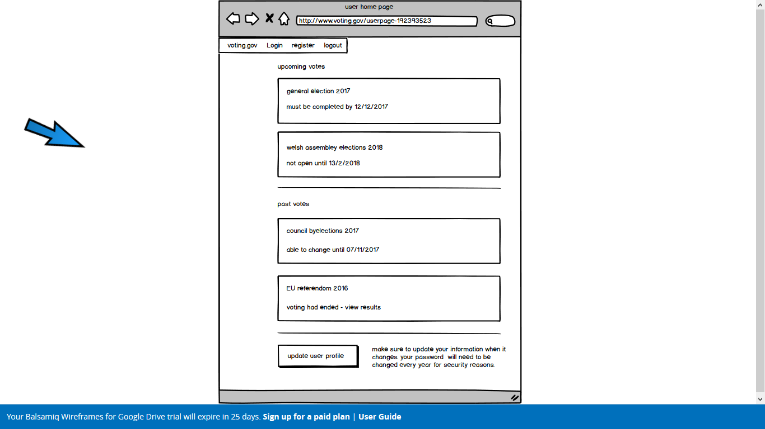

**Account home page**

this is where the user can navigate around their account, displaying upcoming votes and past votes and allowing the person to update their information or log out by the menu at the top.

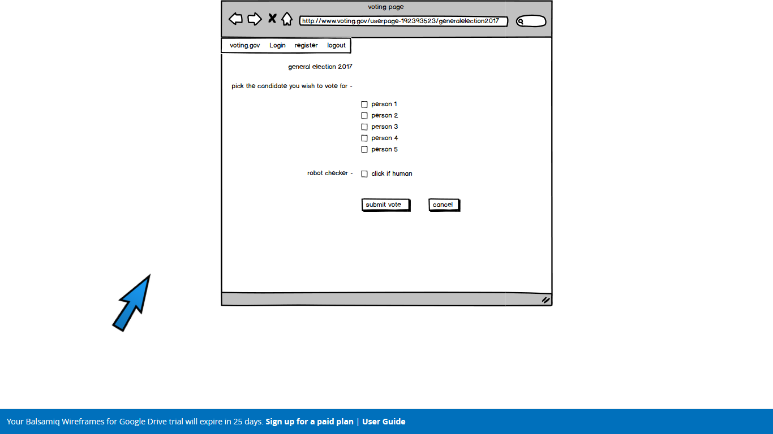

**Voting page**

The user can tick their preferred candidate. Then must pass the robot checker and can then submit or cancel their choice.

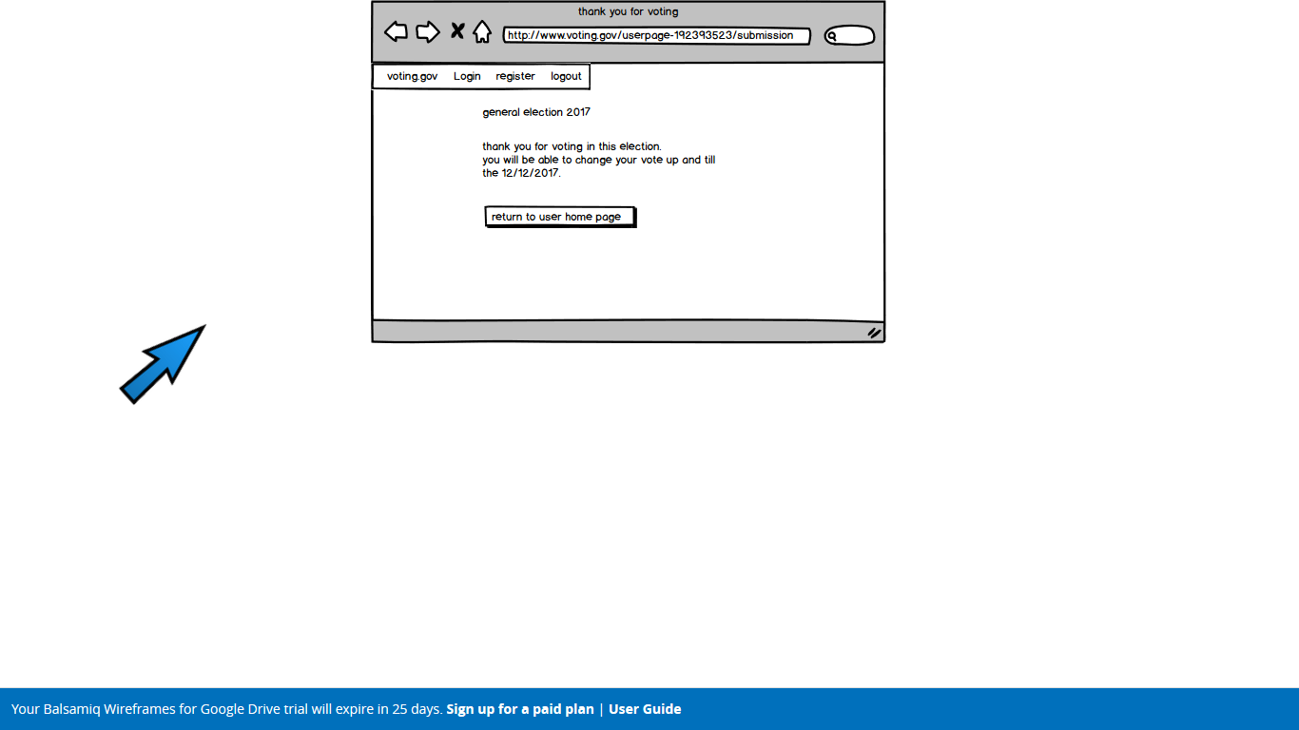

**Submitted vote page**

A page notifying the user of their successful vote and then giving them the option to return to the home page.

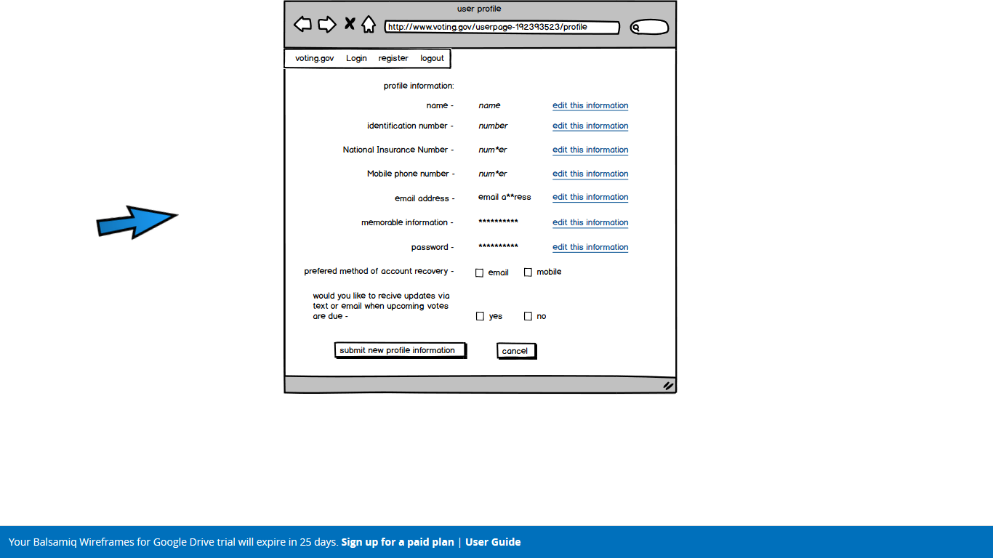

**User profile page**

Allowing the user to view their personal information and links to the editing pages. Plus allowing them to change preferences and defending information against shoulder surfing.

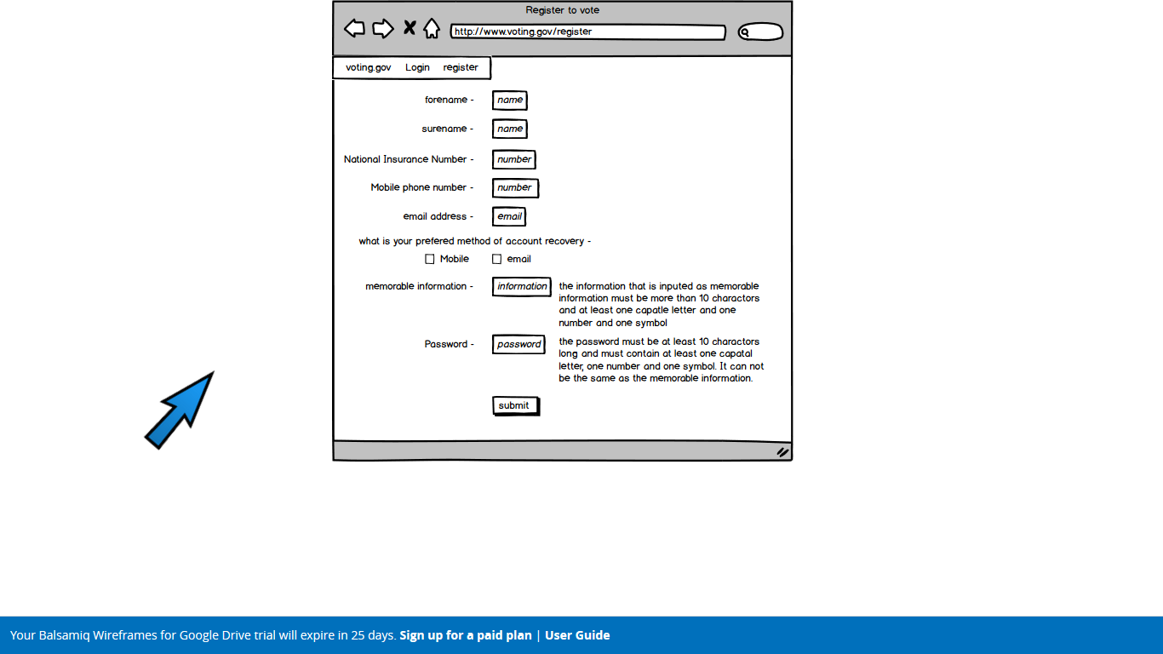

**Register to vote page**

Page that has the open fields to be filled In and gives guidance on how certain fields should be filled in with a submit option at the end.

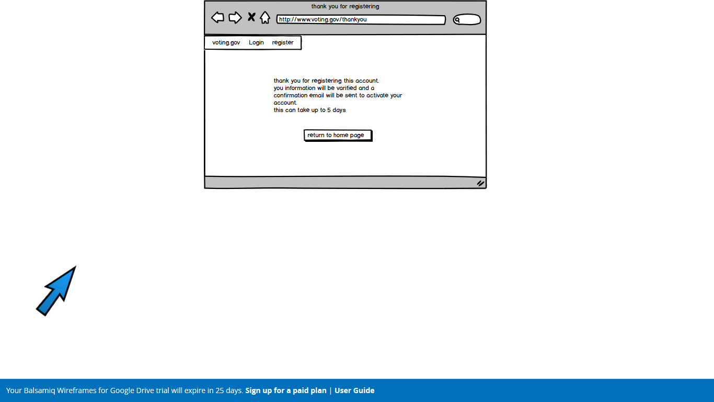

**Submitted vote page**

Page detailing what happens after an account has been registered and the option to return to the home page.

### Evaluation

**Positive Points**

* Simple clear layout
* Unbiased colours
* Uncluttered system of navigation
* No unnecessary content on the site
  + Website’s purpose is clear and transparent
* Clear view of current and past elections
  + Relevant information about dates

**Negative Points**

* Formatting slightly unprofessional
* Jovial font and icon format used
* Possibly too bland with no colours
* Unprofessional grammar used
  + Grammatical errors in places
* Errors in logistics of the website
  + Only 1-step verification used
* Non-official CAPTCHA system used
* Some website sections missing
  + Information about each candidate
  + Statistics about current and past elections

In summary, second prototype has improved vastly on the first. The prototype is generally much clearer and less cluttered, with only relevant sections being used. The account creation system is clear, although it could be refined to make use of 2-step verification. Useful information about upcoming, current, and past elections is well displayed within the user's account. However, the clear style comes across as slightly informal, with comic style graphics and font used; but this can easily be changed to look more formal. On this note, some of the grammar used is incorrect and also comes across as unprofessional, but this can easily be refined to create a more formal tone for the service. Although the website is clear without and strong colours, it may perhaps be too bland; colours can be used subtly to indicate where a user has to navigate to. For example, the button needed to click to proceed can be coloured a slight green as to indicate to proceed.

In terms of service logistics, only 1-step verification has been utilised, with verification being sent to either email or mobile phone. Going forward, 2-step verification should be utilised, as the user's profile is important and linked to their identity in the form of their National Insurance Number. A simple tick box has also been used as the human verification, as opposed to an official CAPTCHA system.

Overall the second prototype is a good improvement on the first, and the areas requiring further refining contain relatively simple issues to rectify. Further sections need to be added, and these will be addressed in the final prototype.

## Prototype 3

### Rationale

This prototype was developed to incorporate many aesthetic features that may have been left out in the simpler prototypes. The intention was to explore the implementation of the many considered optional features that the system could employ but would not be absolutely necessary. In doing so it would then be possible to analyse the system and deduce which of these features is worth implementing, and which of them would simply complicate the process. Some of the features implemented here are the use of different colours, bold and underlining, links to helper pages, additional information, a vote suggestion questionnaire and a two factor authentication page.

## Website homepage

Homepage of the website gives title, register and login options. It uses a plain but subtle yellow background to make the website less bland but not to draw too much attention. This colour is used throughout the system. The colour red is used on the important buttons for emphasis.

**Registration page**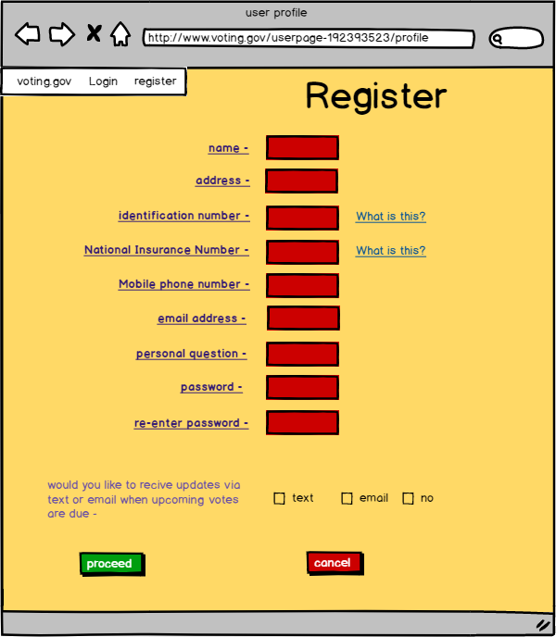

Asks for user details to register for online voting. ID number is of importance as this is used by the system to associate the user with the voter. Mobile phone number and email are required and are used to provide 2 factor authentication. The ‘what is this’ links go to the help page where ID and NIN are explained. Green is used intuitively for the button used to proceed. The colour purple is used to distinguish user details from links.

**Login page**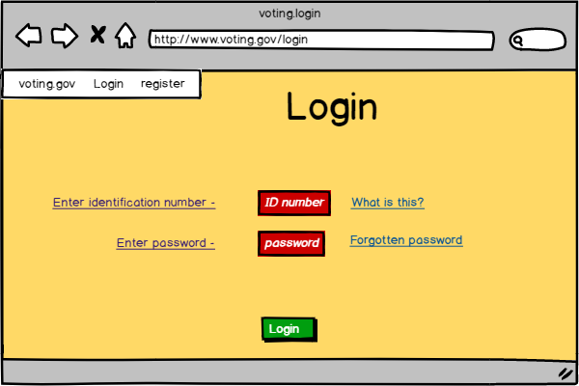

Asks for ID number, which the user would have known previously, likely from being provided it in the post. Also asks for the password which was provided in registration. The forgotten password link goes to the password reset page.

**Password reset**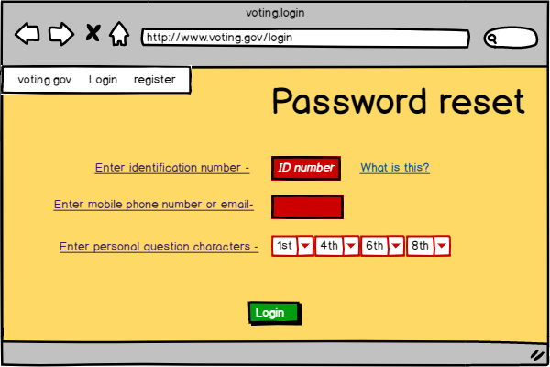

Asks for ID to ensure the user is the voter they purport to be. Phone number or email is used to send a password reset link assuming the personal question characters match the ID. 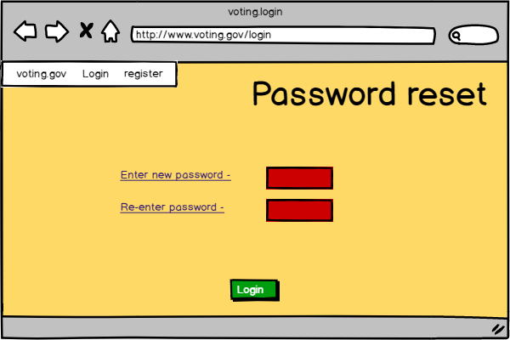

**Password reset 2**

Provides the page to choose a new password after the password reset link is followed.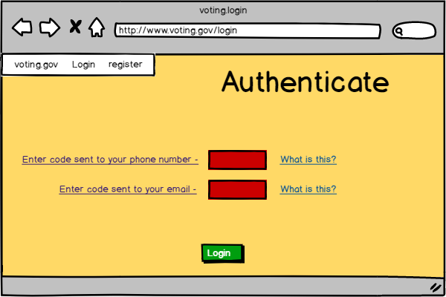

**Authentication page**

Allows the user to enter the code sent to them to ensure 2-factor authentication.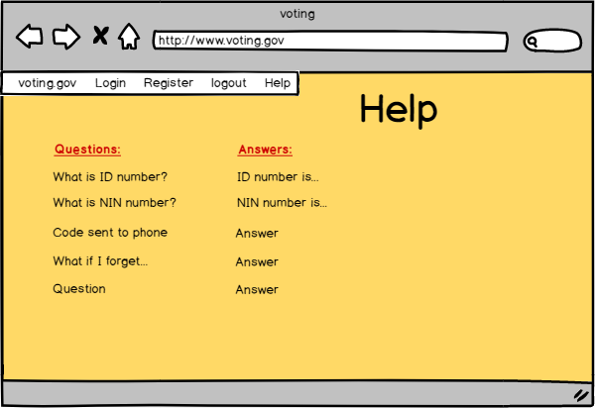

**Help page**

Provides the most common questions and answers regarding the voting website and the general voting process.

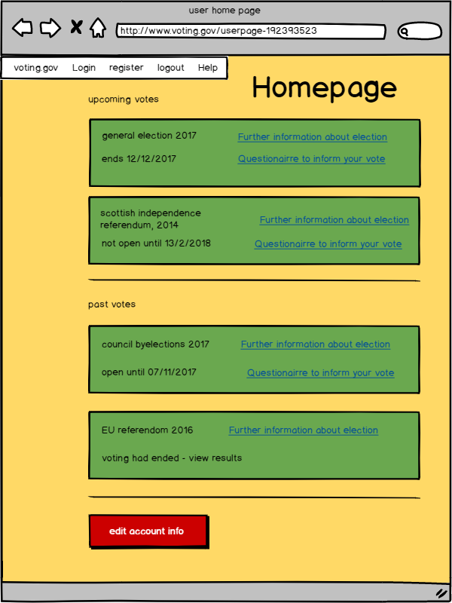

**User homepage**

Details past and future votes, providing links to extra information about each election should the user desire it and also a link to a questionnaire designed to inform unsure voters which candidate most aligns with their views.

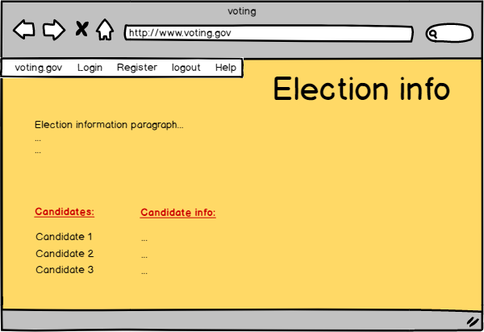

**Election information page**

Simply summarises the election and the candidates involved to better inform users.

**Questionnaire page**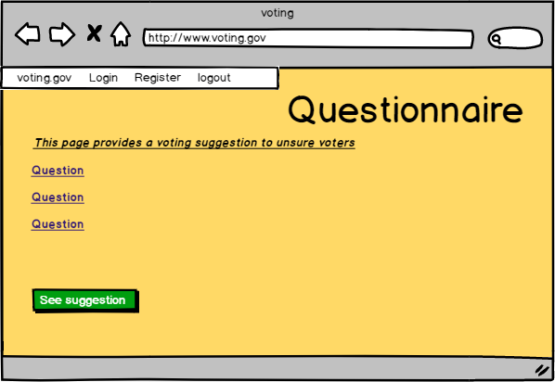

Provides suitable questions to the user and based on this, provides a suggestion of which candidate to vote for.

**Voting page**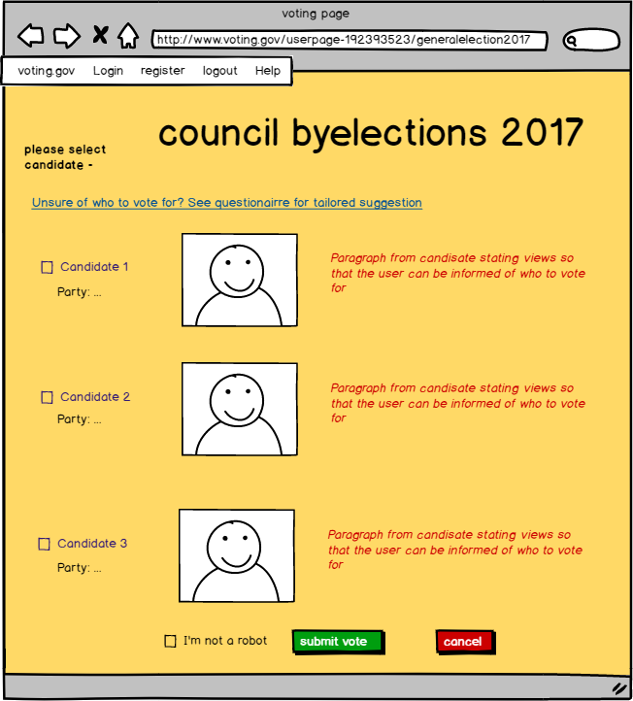

Provides a link to the questionnaire. Shows each candidate’s name, party, picture and a short bit of text approved of by the candidate to promote and explain themselves. Check before vote submission that the user is not a computer bot.

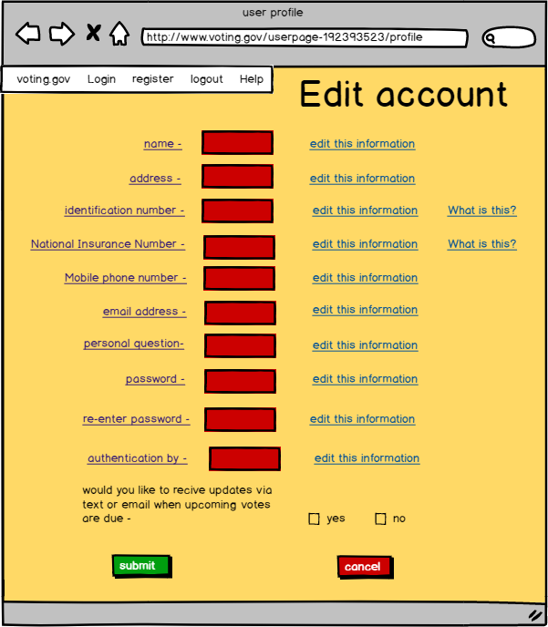

**Account editing page**

Allows the user to update their personal details should they change at any point.

### Evaluation

**Positive points**

* Less bland and so more attractive to the user due to colour use
* Incorporates many features to assist in the use of the system such as forgotten password assistance and the ability to update account details
* Provides access to explanations directly next to respective requests for information, such as explanations of ID number and election information
* Utilises many features to assist the general voting process such as the questionnaire
* Occasional coordination between text and colour to convey ideas such as the use of green for buttons which result in progress
* Uses two factor authentication which would be needed for security. An anti-bot test is also used each time a vote is to be cast

**Negative points**

* Often unnecessary use of colour which may be confusing
* Presentation of too much information side by side which may be too much for the user who may give up, not use the system efficiently or use it incorrectly
* Contrast of colours is often crude and unsightly. Also likely too many colours are used
* Provisional text font should be changed to look more professional
* Questionnaire may be difficult to implement without bias
* Potential information overload on voting page. A simple, clear decision process is essential here.

This prototype was intended to provide an extensive implementation of the features possible and after analysis many of these can be considered appropriate for the final prototype. The use of some, but not too much or too crass, colour should be considered essential. This keeps the website looking attractive and also assists in distinguishing different sections. A compromise should be made to ensure that the colour doesn’t get too distracting, as it often does in this prototype. Forgotten password assistance and user details update features are good as they account for possible difficulties the user may face. Links to the help, election and candidate information pages can inform users unsure of parts of the voting process. This is good as it can ensure that the users are appropriately equipped to vote. This prototype also implements security measures such as two-factor authentication and captcha. These are necessary for ensuring that the voting process is not compromised in any way and the user votes on the own behalf.

The use of colour and general information representation seems to have been taken too far with this prototype as the number of colours and the amount of information can in some places be unsightly or confusing. For example, the colour on the user homepage and the excessive information on the voting page. A more contentious feature is the use of the questionnaire, which could be useful in some cases but has the potential to be manipulated and produce bias results. All things considered it should be omitted just to be safe. The user can be trusted to make their own decision.

# Second Generation Prototype

## Evaluation of tools for constructing prototype

The potential tools considered for creating the second generation prototype were as follows:

* Microsoft Powerpoint
* Balsamiq
* Adobe Dreamweaver
* Basic programming in HTML, CSS and Javascript

Microsoft Powerpoint was considered as it is good for a wide range of applications, even for representing an interactive website due to its ability to incorporate hyperlinks to other slides. However it was concluded to be inappropriate, and rather a crude framework, as it was not designed for prototyping websites. For example things like the browser window would have to be created from scratch, without templates. Also its representation of the system as a slideshow would not have been accurate.

The Balsamiq Wireframes framework was investigated and proved very good in our initial and further use. It is directly meant for modelling and prototyping website interfaces and maintains many useful features to assist in this such as preset browser windows, menu bars and buttons. These made construction of each page much simpler and faster than other frameworks like MS Powerpoint. Crucially, the inclusion of hyperlinks to other pages, again allows the Balsamiq framework to be used as a genuine interactive website would which meant it could be evaluated by real users and against different scenarios.

Adobe Dreamweaver could unfortunately not be used due to financial considerations.

Website design via programming in HTML, CSS and Javascript was deemed to be unnecessary and excessive. It would have been possible to use these tools although they are intended for the final system implementation and so a simpler model would be far less time consuming and allow easier alteration during the prototype design process.

After consideration of all these tools, Balsamiq was decided to be the most convenient and most appropriate tools for constructing the second generation prototype.

## Description

**Website homepage**

Asks the user to choose between logging in if they’ve already registered and registering if this is their first time with the system. Both will send them to other pages on the system domain. The page is very minimalist and very clear with the two progression sections emphasised with green buttons.

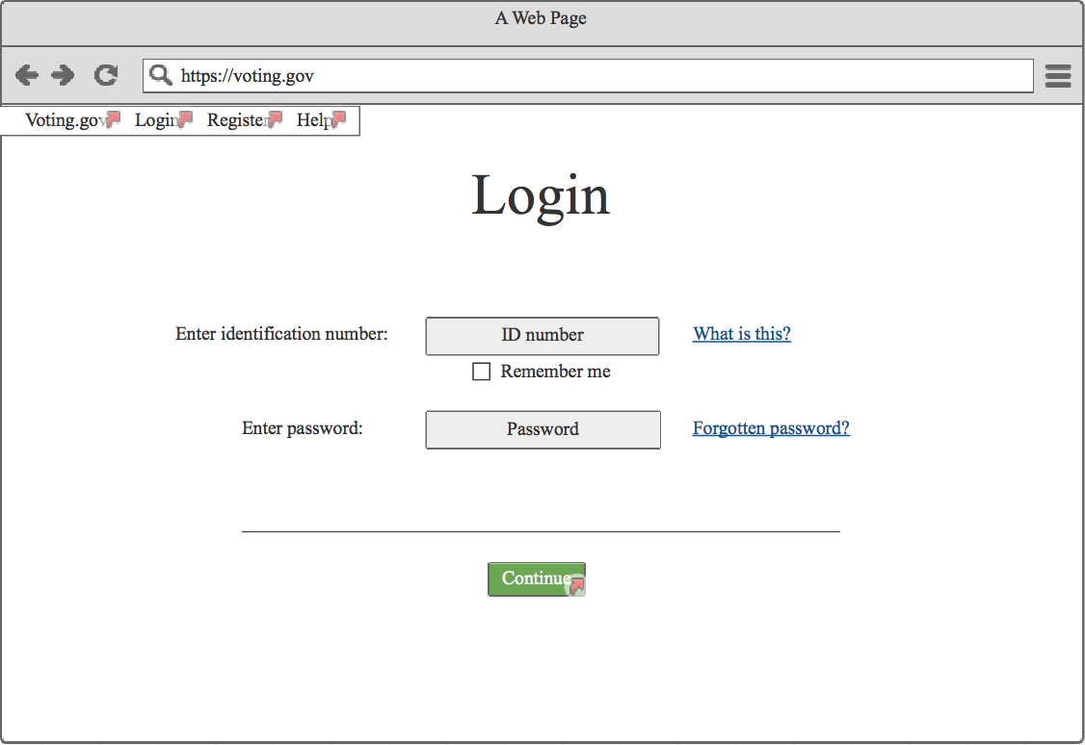

**Login page**

The login page for users to login with their unique identification number and password. Links are given to retrieve a forgotten password and receive information about their unique ID if unsure.

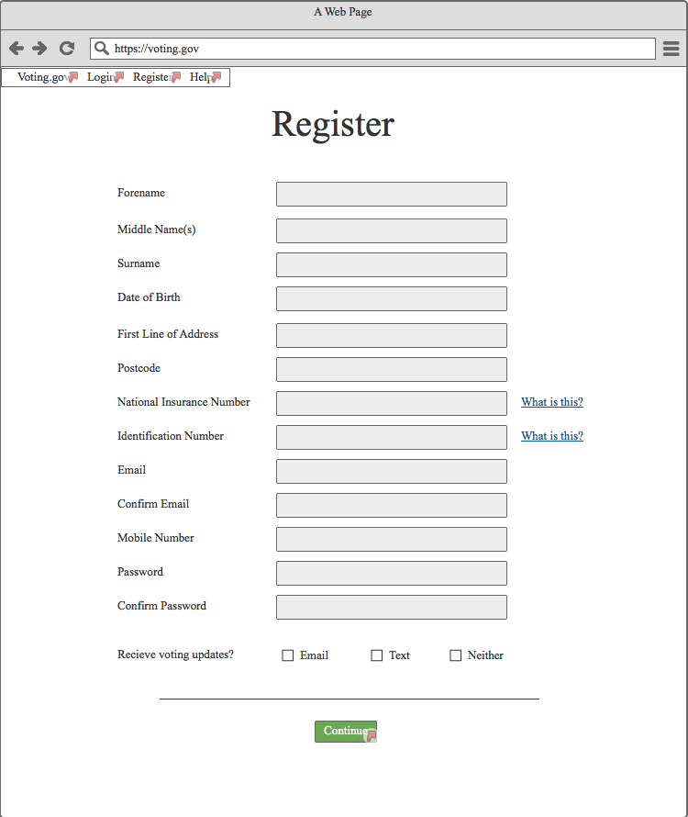

**Registration form**

Registration page for users to fill out relevant information about themselves. This is to ensure contact information is up to date and is used to create a password and define contact preferences.

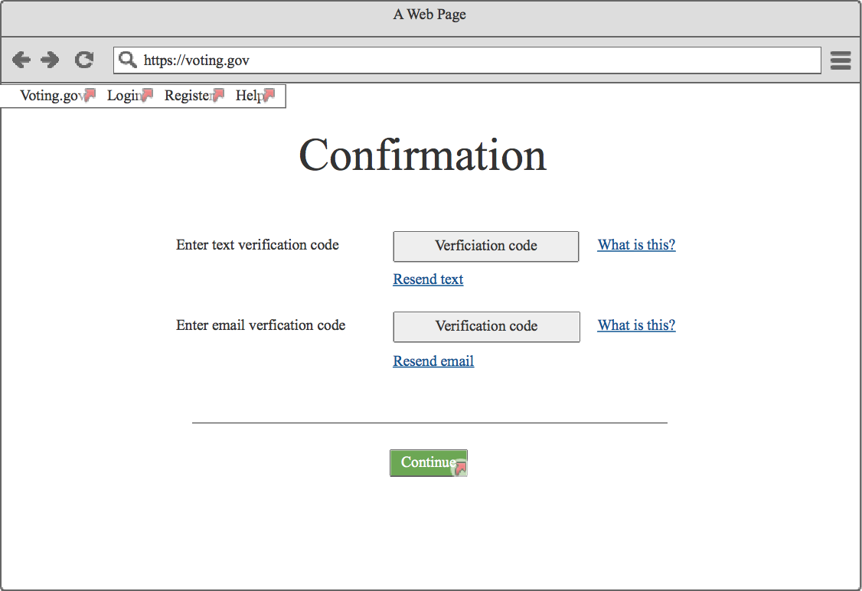

**Confirmation page**

The confirmation page given after account creation. This is to verify their identity via 2-step verification with both email and text. Links are provided to clarify what to do and to resend the messages if they failed to deliver.

**User home page** 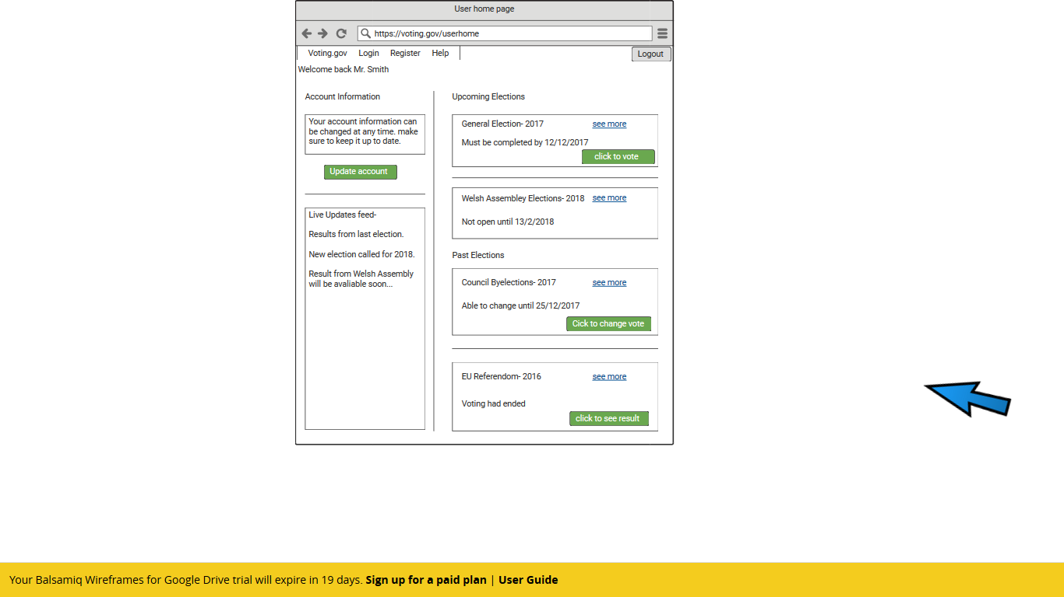

This page contains the links to the separate parts of the user’s profile like the votes they are eligible for, their account and a live news feed.

**Electoral page**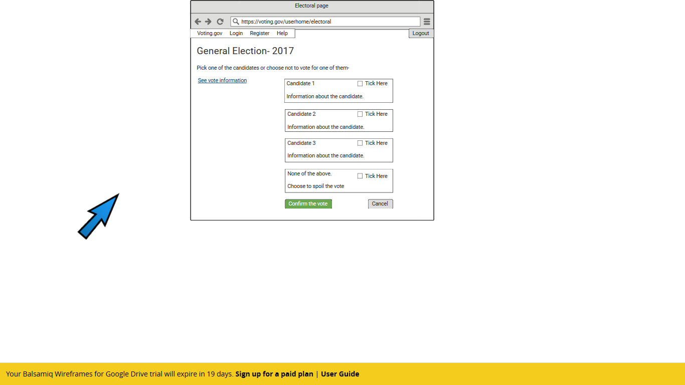

Where the user can select their chosen candidate for the particular election and then submit their choice.

**Confirmation of vote page** 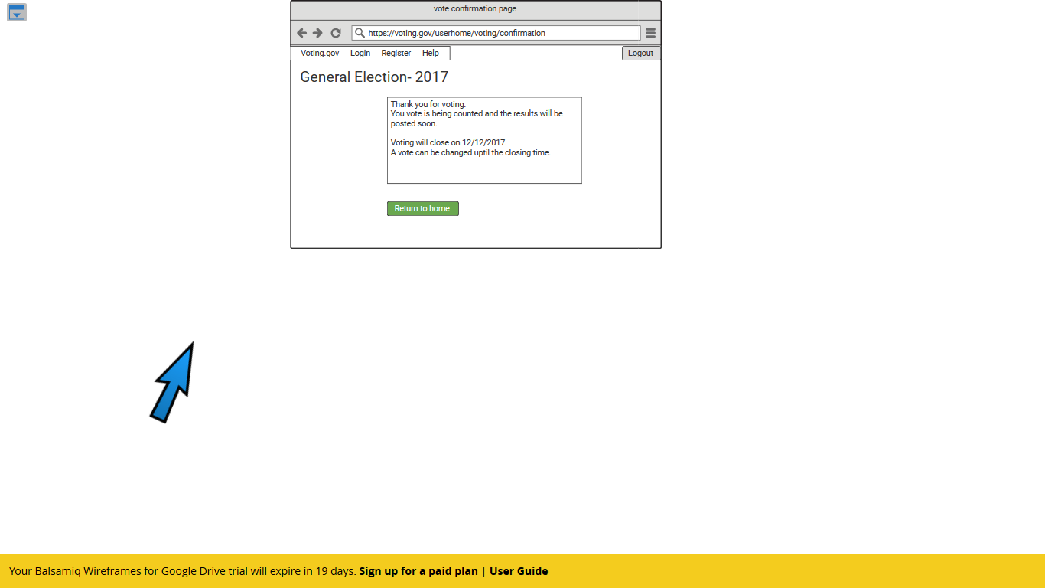

Page confirming that the vote has been cast effectively and giving the option to return to the user home page.

## 

**Help page**

This page consists of the most essential questions relating to the system and their answers. It is given a separate page so that it doesn’t make the other pages overcrowded. The user can either navigate to this page via the menu tabs at the top of the page or may be directed after pressing a ‘what is this?’ link from another page. This page will open in a new tab so as not to lose any information that may have been input beforehand.

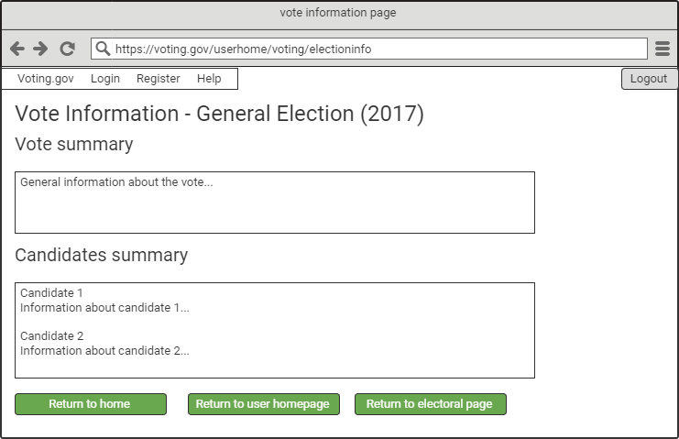

**Vote information page**

This page contain the basic essential information that a user may need to develop an informed opinion about who they want to vote for; general vote information and information about each of the candidates. This page is linked to in appropriate places on the user homepage and electoral pages so as to assist the user when they are deciding on their vote.

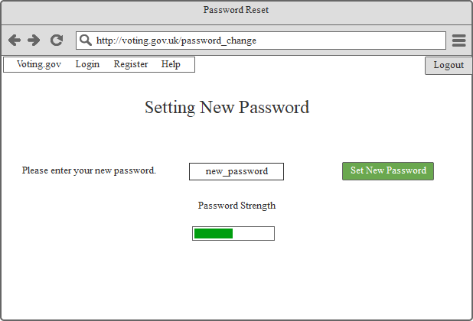

**Setting New Password**

Users will be directed to this page if they click the “Change your password” in the user information page.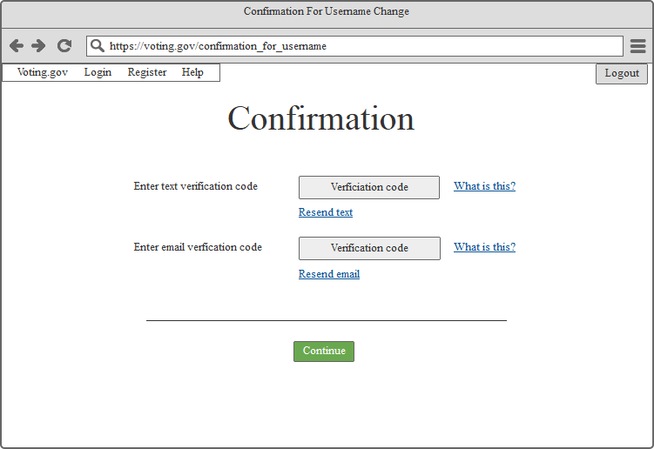

**Confirmation**

Users will have to enter the verification code to the related fields to change their passwords.

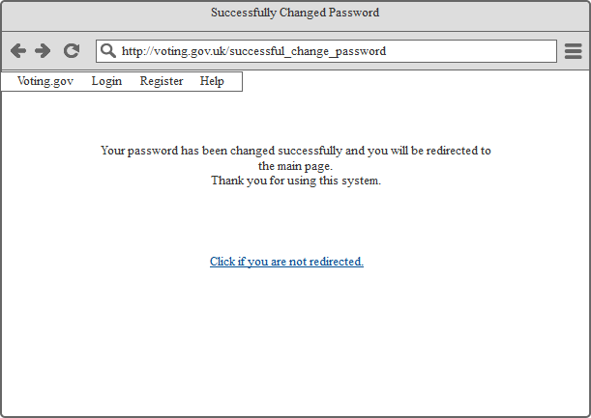

**Feedback Message**

Users will be directed to a page which has the feedback message says their password has been changed successfully.

**Confirmation**

Users will have to enter the verification code to the related fields to change their usernames.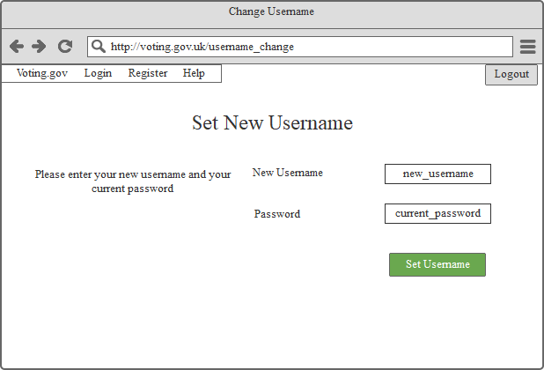

**Set New Username**

To change their usernames, users will have to write their current password and the new username they wish to have after confirmation. They will be directed to the feedback page afterwards.

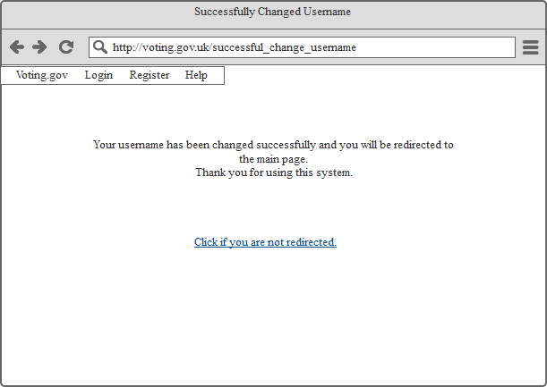

**Feedback Message**

This message will be shown to the user to say their password has been changed successfully.

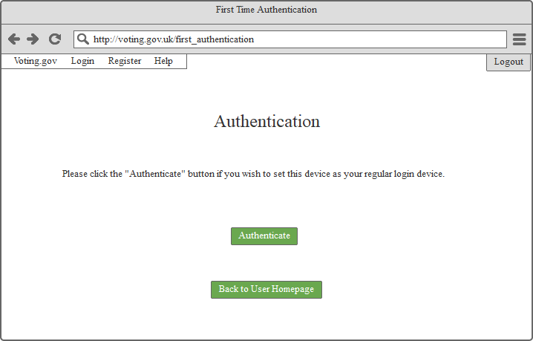

**Authentication**

Users can authenticate a device they use to set it as their regular login device. Once they click the button “Authenticate”, the device will be known to system to avoid logins from another sources.

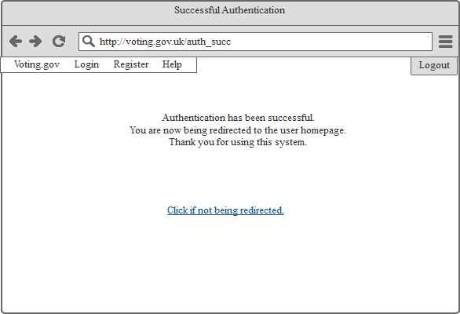

**Successful Authentication**

Users will see this message page after they are done with authentication process.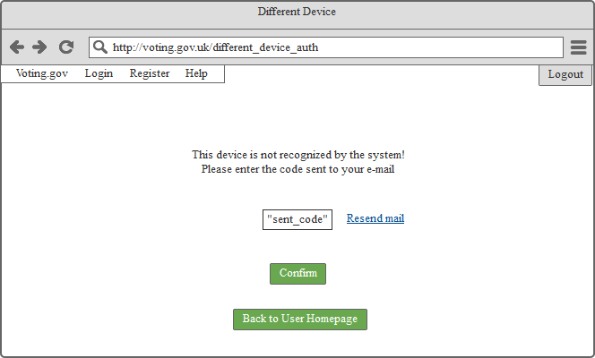

**Unknown Device**

If users try to login an account from an unauthorized device, they will be directed to this page in which they will receive a verification code via e-Mail. Once they enter the code they will be directed to the user homepage.

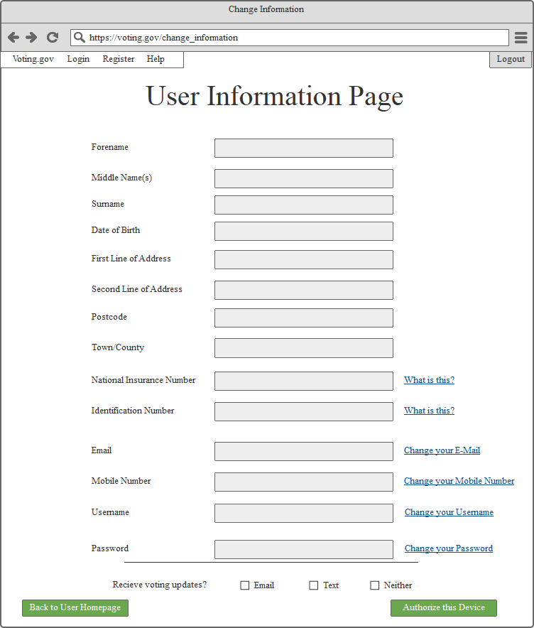

**User Information Page**

This page can be accessed from User Homepage. Users can change their information from this page. They need to click the related “Change your ….” Button to access the pages to change their related information.

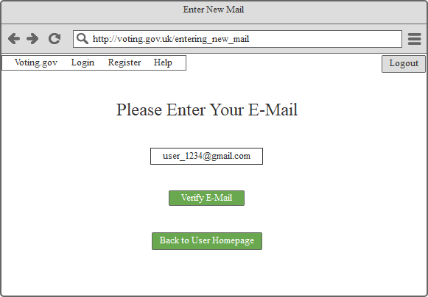

**Entering New E-Mail**

User will be directed to this page if they click the “Change your E-Mail” button in User Information Page. They will receive a mail on their new address which will have a verification code.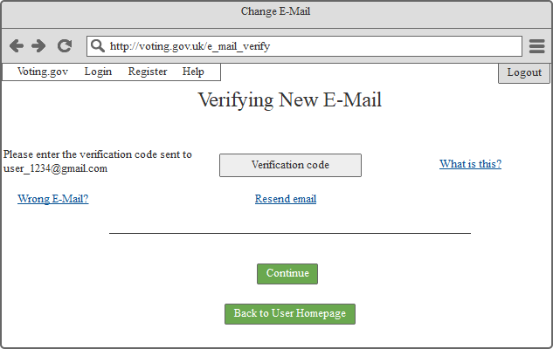

**Verifying the New E-Mail**

Users must enter the verification code sent to them to the related text input. System will accept the new e-Mail after this step is done.

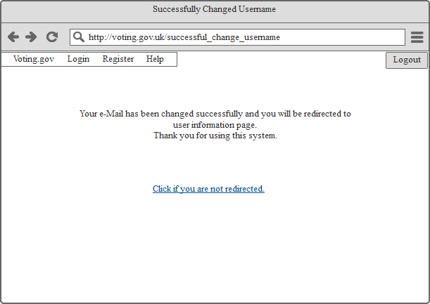

**Feedback Message**

Finally, users will be directed to this page if they successfully changed their e-Mails.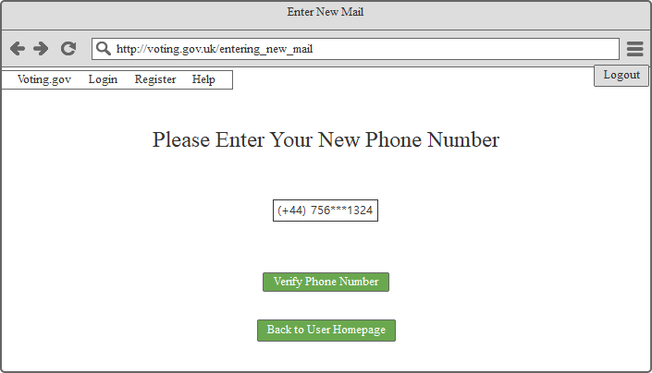

**Entering New Phone Number**

Changing the phone number has the same process as changing the e-Mail. Users will enter their new phone number and they will receive a text on their new number.

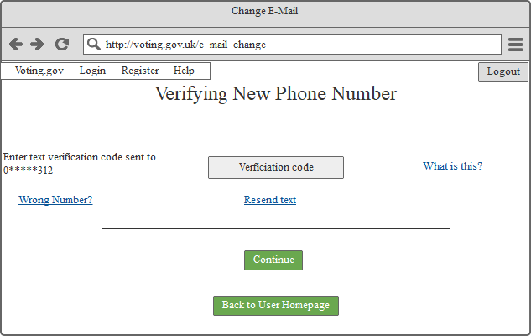

**Verifying New Number**

Once the user enter the verification code they have received on their phones, system will accept the change.

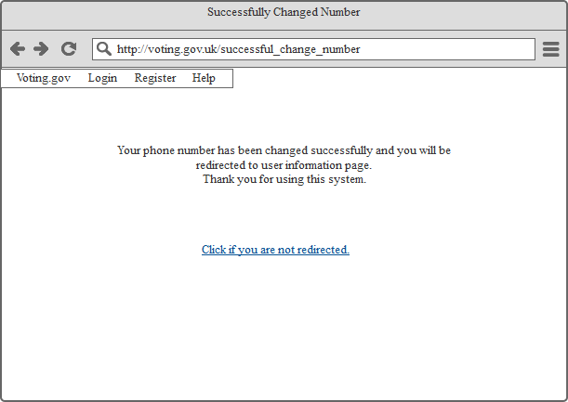

**Feedback Message**

Finally, users will be directed to this page if they successfully changed their phone numbers.

## Evaluation of Second Generation Prototype

Evaluation of the second generation prototype was done in three steps according to the ten steps for heuristic analysis of a system. The three steps were generally assessed analysis, assessment against persona scenarios and assessment against genuine user tests.

### Heuristics general evaluation:

Using 3 scenarios from the three different personas, we can speculate as to a variety of different experiences, outside of any first hand testing with users. The three persona scenarios to be used are firstly 22 year old Tom Griffin, in the first scenario where his desire to vote has fallen. Secondly 45 year old John Reynolds in the second scenario where he is very tired from working, but in this case is able to use online voting. Finally 63 year old Amy Adams in the second scenario where she is tight for time.

**1.Visibility of System Status**

“Insert the slides here” (write-ups).

With confirmation and excluding the message times, system takes “7” clicks to complete voting process. It feels quick and easy to use.

**2.Match between the system and the real world**

System is clear and uses basic instructions to help people. While creating an account, there is a password strength meter which helps with security but there are no conditions on how to make the password (e.g. Password must be at least 8 letters and it should contain at least one uppercase letter, one lowercase letter and it must include a punctuation mark). Not all people are interested in politics, to help the voters there are unbiased summaries about candidates to help those people.

**3.User control and freedom**

System guides the user on not only how to go through the voting phase. It helps the users to change their information at any given time. People can select the wrong candidate, or they can change their minds. System gives the chance to change the given vote to users. Users can go back to their user homepage or the general homepage from every page in this system. They have the option to log out anytime they want. Users can go to related previous pages and they can cancel their actions.

**4.Consistency and Standards**

System has the same interface for every user. Instructions are the same for every user and for people who may not understand the instructions, they can access the “Help” page easily to look for extra details. There are “what is this” buttons next to the fields which may not be understood (e.g. National Insurance Number in User Information Page).

**5.Error Prevention**

With basic instructions and confirmation pages, system tries to prevent the user related errors. In confirmation pages, if users do not receive their emails or texts they can be sent again with user pressing the related button. When sending the verification codes for changing E-Mail and Phone Number, the information typed by the user is shown to the user again in the verification process to avoid wrong inputs. If they write wrong number or e-mail, in the texts and emails there are no information about the user. It will not include any information about the user.

**6.Recognition rather than recall**

System lacks in this department. It expects some information to be known by the user such as how to make a password better. Information such as National Insurance Number, Identification Number, they are checked by the system if it is true or not. There is no example format to help the user while writing their e-mails or their phone numbers. If user writes the date of birth in a wrong format, they will be warned by the system.

**7.Flexibility and efficiency of use**

As it was mentioned, system does not require much action in the voting process and it allows necessary actions such as cancelling the current actions or logouts. There are no macros used by the system to help the user. It is easy to navigate through the system. Users can change their actions if they make any mistakes.

**8.Aesthetic and Minimalist Design**

This system needs to be as simple as possible to help people because an entire population will use this system. It has only the relevant information in the pages. It does not have unnecessary input sections or unnecessary navigation choices through the system.

**9.Helping Users Recognize, Diagnose and Recover from Errors**

After changing information, users will be directed to the User Information Page in which they can check if they have entered it correct. Confirmation and verification of the related information helps the users to check if there are any errors and it helps with security. Users can change their votes if they have made an error, they can change their information if they have entered it wrong. Therefore, system helps the users recover from errors.

**10.Help and Documentation**

Help Page provides explanation on relevant information. There is no search option in the system because it has only several pages user needs to go through and actions they need to take. There is no list of subjects to be carried out to vote which may be successful to the users but system being focused on only voting negates that.

### Heuristics persona evaluation:

Using 3 scenarios from the three different personas, we can speculate as to a variety of different experiences, outside of any first hand testing with users. The three persona scenarios to be used are firstly 22 year old Tom Griffin, in the first scenario where his desire to vote has fallen. Secondly 45 year old John Reynolds in the second scenario where he is very tired from working, but in this case is able to use online voting. Finally 63 year old Amy Adams in the second scenario where she is tight for time.

**1.Visibility of System Status**

With the first persona, Tom should notice the menu bars on each page associated with the page titles to determine whereabouts in the system process he is. In the second and third personas, they may not notice the menu bar as they are tired and rushed respectively.

**2.Match between the system and the real world**

All personas are assumed to be proficient in english and so able to understand the simple language used. The only persona who would have difficulty is Amy Adams who is not very well accustomed to using computer systems. This being said it is a relatively simple system to navigate with very basic page layouts and so should be intuitive.

**3.User control and freedom**

For Tom Griffin, his lack of desire to vote scenario may mean that the use of vote and candidate information pages informs him of a lot of information he wouldn’t otherwise have known. For the other two personas, the option to view this information is not compulsory and does not take up much attention or space and so no user would feel compelled forced into viewing.

**4.Consistency and Standards**

The interface is not only the same for each user, it also follows consistent formats among the different pages. In separate scenarios where young Tom wants to update his email to a more professional looking address and tired John can’t be bothered to go find the piece of paper where his password is written, the pages for entering a new email address and setting a new password are of consistent format, meaning it’s consistency can be considered good.

**5.Error Prevention**

In the scenario where Tom is indifferent about the vote, but has chosen the option to be reminded about it, he will therefore still be able to vote even if he had forgotten about it. In the scenario where John’s tiredness makes him forget his primary (laptop) device at work, the system can deal with this by allowing him to authenticate a new device that he might use by email, which maintains security despite his mistake. In the scenario where old aged Amy forgets her password, the system allows her to set a new one. The system seems to account for this range of errors from these scenarios well.

**6.Recognition rather than recall**

In all scenarios, of all the information that is first required to be input for registration, only ID number and password are required for each consequent login. This is useful as tired John would not want to have to put in a lot of information and tight-for-time Amy would not have time to. In each scenario the system stores the user ID number using cookies if the user clicks the ‘remember me’ option. The system’s use of recognition therefore appears acceptable.

**7.Flexibility and efficiency of use**

In all three persona scenarios, where they are all not wanting to expand too much effort, the system has a very efficient, simple and clear design allowing the user to get from the login page to having submitted the vote in just 4 links (clicks). If in the case of 22 year old indifferent Tom, he decided to use the vote information page, this would only result in 6 clicks total as this page opens in a new tab, which closes on pressing the return button. This allows the information the user previously inputted to remain undisturbed.

**8.Aesthetic and Minimalist Design**

For all personas the system should seems equally minimalistic and simple with very few items and interactive pieces on each page and very little information, only that which is necessary. In the case of 63 year old Amy Adams, even a little too much information would make the system extremely difficult for her due to her age and lack of experience using computer systems. Thankfully the design is suitably minimalistic such, even on the voting page which has only name, respective information, and vote option for each candidate, with further separated options to submit vote, cancel and link to another page with election info. This simple design should be appropriate for all personas.

**9.Helping Users Recognize, Diagnose and Recover from Errors**

One scenario with Tom could be that being a student he is unfamiliar with his national insurance number having been at university and not yet need to pay taxes. He inputs his NIN into the ID number field in the login and is confused when it doesn't let him progress, he therefore sees the nearby placed ‘What is this?’ link and clicks it to find out what he did wrong. It takes him to the help page which reminds him what his ID number is and where he can find it. He can then input the correct ID number and progress to vote. Another scenario would be where John accidently inputs the wrong information in his registration page such as the option to be notified of voting updates. The system then allows him to update this information via the user information page. In these cases the system works well, although in the case where Amy tries to use the system to login and her son has previously logged in, the system may initially assume that the ID number is that of her son instead of her. The system should in implementation show a full list of all past user ID numbers. All things considered, the system helps users with error quite well for the persona scenarios.

**10.Help and Documentation**

In the scenario where busy John Reynolds has spent so much time working that he has missed out on keeping up to date with the current vote, the system provided the option to view information about the election. In a scenario where Amy, who is not great with computers, is having difficulty navigating and using the system, the easy to reach help page on the menu bar provides an intuitive and readily available source of help and information to assist her. If the user gets confused in any other scenario, help is always on hand with the system, and so overall the systems seems to rate well in this category for the scenarios.

### Heuristics users evaluation:

Three persons were asked to use the system and then asked to evaluate it on the 10 heuristics and their opinions have been collated. Person 1 is a biomedical student of the university, person 2 a retired grandparent and person 3 a farther in his mid-50s.

**1.Visibility of System Status:**

Person 1- they expressed that they find it a simple enough system to understand where they are in it even though it does not advertise where they are in the system with breadcrumbs or a process bar. It’s fairly self-explanatory to know where along the process the user is, and it doesn’t seem to take an unreasonable length to complete.

Person 2- being unfamiliar with completing many online registrations this system didn’t seem very long for this user. They had no idea where they were along the process, but this didn’t seem to be a major problem.

Person 3- they also expressed a lack of knowledge as to their position but stated that this is not a problem for them as the importance of casting the vote is superior and the ability to cast it anytime of day means they can do it when they are free.

**2.Match between the system and the real world:**

Person 1- irrespective of their lack of an in-depth knowledge of voting in elections it was not too jargon filled and their knowledge of registering accounts before aided them.

Person 2- found some of it to be a faff and challenge switching between emails and the webpage. The language was a little challenging but nothing that couldn’t be overcome with reference to the help page.

Person 3- the system gave a good enough description of what was required as certain point and they had no major problems with understanding the language.

**3.User control and freedom:**

Person 1- there is the option to change the vote and cancel it before submitting and after submitting and this is all the freedom that they wished to have.

Person 2- they didn’t feel like they were being forced down a single path but rather going where they wanted with guidance. Found the guidance on their ability to cancel or resubmit their choices was adequate.

Person 3- they felt that this amount of ability to change their choices was good for some people but also that it detracted from the absolute nature of casting a vote as voting has never been able to be changed before and so unsure if that may affect the way people vote due to the sway the media has in public opinion.

**4.Consistency and Standards:**

Person 1- looking at the website design they believe that it is consistent in its layout like the information change page and registration page are very similar, the same colours are used for the buttons and the fields.

Person 2- they thought that the different pages looked similar and like they were all part of the same website.

Person 3- they believed that it was a consistent design with colour meanings stuck to and that it was similar to the design of the .gov webpages giving it an official standard.

**5.Error Prevention:**

Person 1- when using the webpage, they said that they didn’t make any errors but were unsure if this was because of the system design or because they were focusing on what they were writing, although that is what they would do if they were doing it for real.

Person 2- they thought that there was the lack of a field lighting up red when it was entered wrong and on the registration section there was no chance to review the information they had inputted to see if it is correct.

Person 3- they system requires the user to input their email and password twice like a normal system would require so those information’s are protected from errors but a information review stage would be useful.

**6.Recognition rather than recall:**

Person 1- the load on their memory was not too strained in their opinion, they had to find all the information required but didn’t have to remember it. The system allows for the user ID to be remembered after the first login but apart from that they must either remember everything else or write it down.

Person 2- they have all their information writing in a single place and didn’t feel like this was a security issue.

Person 3- they noticed that the fields didn’t have sample formats in them, so it is slightly ambiguous as to how to display the date of birth as it can come in different formats. They didn’t find the amount of information they had to remember to be too much of a challenge for them.

**7.Flexibility and efficiency of use:**

Person 1- is doesn’t require a person to have to enter information more than once like during the registration everything is only added once apart from the email and password which is normal to re-enter. It has return buttons at all stages so that the homepage or to logout can be accessed which is good.

Person 2- it is fairly efficient, no information has to be entered needlessly, and the clear navigation means it's efficient to get around.

Person 3- they did not think that it was particularly inefficient, its navigation buttons lead to the right places meaning that they could efficiently navigate around the site.

**8.Aesthetic and Minimalist Design:**

Person 1- the design is very minimalist. It doesn’t have distracting colours or information that is not relevant to the task of the page. Aesthetically it is not the most pleasing website to use but its purpose is for functionality and not visual pleasure.

Person 2- all the information on the page is relevant and important so they wouldn’t say that it is at all overcrowded. The aesthetic is quite plain but to their liking as they aren’t a fan of busy pages.

Person 3- approve of the simple design and the aesthetic that would not be out of place in a .gov webpage. The simple colours avoid party bias.

**9.Helping Users Recognize, Diagnose and Recover from Errors:**

Person 1- they don’t have the opportunity to recognise errors during the registration process and it would be until they check their information that they would probably notice so the recognition is not so good.

Person 2- it could do with coming up with red errors if something is not entered correctly.

Person 3- the recognition of errors is not substantial, but this should surely be up to the person to make sure they enter it correctly, it’s hardly a difficult task to write their own name and address and so on.

**10.Help and Documentation:**

Person 1- there is a help page on offer if help is needed but the fields offer guidance as to how they should be filled in and where they don’t they are self-explanatory. Doesn’t give information as to the minimum requirements of the password just a bar.

Person 2- the help page is useful and there are links to it next to all the fields that were unfamiliar.

Person 3- the documentation is sufficient in their opinion, it covers what the fields are that should be filled in and it covers what the buttons do and where they go or what they do. They found no trouble in using it.

**Severity Ratings**

|  |  |  |  |
| --- | --- | --- | --- |
|  | **General heuristic** | **Scenarios** | **Users** |
| **1.** | **0** | **1** | **1** |
| **2.** | **1** | **1** | **0** |
| **3.** | **0** | **0** | **1** |
| **4.** | **0** | **0** | **0** |
| **5.** | **1** | **2** | **2** |
| **6.** | **2** | **1** | **1** |
| **7.** | **2** | **1** | **0** |
| **8.** | **0** | **0** | **0** |
| **9.** | **1** | **1** | **1** |
| **10.** | **0** | **0** | **0** |

## Results and Conclusion

The final prototype produced is a large improvement on the first, with a much-refined style and layout. Improvements in skill with the production software has allowed the 2nd generation prototype to a more accurate representation of the vision of the creators. A clear and unbiased colour scheme was adopted once again. This was for two reasons: any sort of colour scheme was ultimately distracting and could potentially add bias to the website if any political parties used said colour scheme. The second reason was to adopt the uniform style of most of the .gov websites; with clear block colours and mostly blacks and whites. Green was chosen for the confirmation buttons, as it is an intuitive colour to proceed or go in society. Although some political parties may have green in their colours, we believe the underlying meaning of green to proceed outweighs the potential bias people may feel.  
  
The font and style of the graphics were updated to a less comic style. This reflects the more serious tone of the website, and it sitting with other .gov websites. However, it is worth noting that due to the limitations of the software Balsamiq used to develop the prototype, the final realisation of the website may be different to the prototype, as it would be developed by web developers and graphics teams using various web design languages.  
  
Various features were explored and expanded upon in the final prototype, such as 2-step verification, via both email and text. This brings the much-needed security to the prototype, in a clear and easy to understand manner.  
  
Overall the 2nd generation prototype is well rounded and an accurate representation of the final website. Improvements have been made after feedback from each iteration of the first generation prototypes.

# Summary and Recommendations

This report summarises the work carried out in trying to design a human-computer related solution to a perceived problem. The problem addressed concerns the current voting system, particularly that of the UK, and the many ways in which it is imperfect and could be improved upon. At the moment, there is a decline in the proportion of people voting and this can be attributed in part to the difficulties people have with traditional postal or polling station voting. The high cost of present day elections and votes is also another issue, along with the inevitable inaccuracies that occur when humans need to count the votes themselves. It was speculated initially that an online voting website system could potentially improve upon the voting system in these areas and others by making voting more convenient, cheaper and more reliable. The online system would be used in conjunction with traditional voting so as to leave voters with a choice.  
  
To conduct the votes, First Past the Post system will be implemented to our online voting system as it is the system used in the United Kingdom considering that devolved regions implementing different methods. The term of cybervoting is first used in 1995 regarding a French nuclear testing in the Pacific region ("The Age, Melbourne", 1995). Finland is working on the introduction for National Online Voting ("Finnish Government: Introduction of internet voting set as goal - Oikeusministeriö - Oikeusministeriö", 2017). Estonia held the first National Internet Election of the world in 2007 ("Estonia to hold first national Internet election - CNET News", 2017). Estonia’s system provides just enough information about election process and upcoming elections. It has a help section for users, but they do not offer much assistance to visually impaired citizens. The system has a very clear layout and precautions to protect anonymity which helps with trust. Main issues with the proposal of an online voting system to people is the security part of it. People need to trust the system and its anonymity. Layout must be unbiased and must not include any political views. The system must be accessible and must allow equal opportunity to vote to all people without taking their physical or mental impairments on the account. ("Introducing E-Voting - Considerations —", 2017) For our system it will be designed as a website, not as an application as Estonia’s system. As mentioned on Lloyds Bank System, user IDs must be unique, and password should have more than 8 letters with including a number and an uppercase letter. System’s layout must be clear with a simple background and a visible foreground content which will not include excessively large texts. Highest priority tasks must stand out with unnecessary information. All these criteria must be balanced. ("Utilizing LibQUAL+® to Identify Best Practices in Academic Research Li" by Raynna Bowlby, Brinley Franklin et al.", 2017) Analysis of current voting like websites such as the .gov petitions page made it clear which aspects of websites should and should not be incorporated for a system to be successful. The main points were that it should be minimalist, only moderately colourful and consistent and simple in design.  
   
A survey was carried out to investigate public opinions on the current UK voting systems. This was done so as to better inform our design of an alternative system in a user friendly way. Conclusions from the survey were that it should be easy to use, secure and clear. Also that people are not entirely satisfied with the current system and most would be willing to vote online if it became an option.   
  
Before designing the system, work was done to develop different user requirement profiles. These consisted of three typical fictional users which could accurately represent a wide range of different potential system users. For each their basic characteristics were provided, such as age and occupation, a general description, main point, goals, pain points and fictitious scenarios. For the range of users considered, these aspects were used to guide later designs for the online system.  
  
The first stage of constructing a online system was done via three low fidelity prototypes. Each were made according to distinct rationales; the first was to implement a system which made many mistakes in order to highlight what should be avoided, the second was to make an overly simple prototype and the third was to try and include all the potential features in an attempt to find the most appropriate ones for the final design. Positives and negatives were found for each prototype and the main conclusions included that we include a very small amount of well placed colour, in for instance the important buttons, that help and vote information pages are included along with implemented security measures, not overloading the user with unnecessary information and accounting for possible user errors like forgetting their password. These recommendations were used to inform the final prototype.  
  
A second generation prototype was constructed based on all the previous research and work done. Analysis of potential tools led to the use of the Balsamiq Wireframes as the framework for constructing this prototype due to it easy of use and appropriate design for making website designs. After producing this final prototype, it was shown page by page with descriptions at each stage. After this it was outlined how the evaluation would be carried out, with analysis conducted generally, against persona scenarios and against user testing. These were evaluated quantitatively via ten heuristic steps and their respective severity scores from zero to five for each of the three types of analysis. The best characteristics of second prototypes were then concluded to be its user assistance, consistency, minimalism and help/documentation. It faired worse in the error prevention, information recall and flexibility/efficiency categories where extra work was recommended for a future system.

# References

1. First Past the Post. (2017). Electoral-reform.org.uk. Retrieved 1 November 2017, from <https://www.electoral-reform.org.uk/voting-systems/types-of-voting-system/first-past-the-post/>

2. Single Transferable Vote. (2017). Electoral-reform.org.uk. Retrieved 1 November 2017, from <https://www.electoral-reform.org.uk/voting-systems/types-of-voting-system/single-transferable-vote/>

3. The Age, Melbourne. (1995). WebArchive. Retrieved 1 November 2017, from <https://web.archive.org/web/20120326110849/http:/www.midac.com.au/Archive/CyberVote/Subject%20International%20Internet%20NewsClips___%20From%20madanmohan%20rao%20rao%40igc_apc_org%20Date%20Wed%2C%2013%20Sep%201995%20194547%20-0700.htm>

4. Estonia to hold first national Internet election - CNET News. (2017). archive.is. Retrieved 1 November 2017, from <https://archive.is/20120713191050/http://news.com.com/Estonia+to+hold+first+national+Internet+election/2100-1028_3-6161005.html>

5. Internet Voting - Voting methods in Estonia - Estonian National Electoral Committee. (2017). Vvk.ee. Retrieved 1 November 2017, from <http://www.vvk.ee/voting-methods-in-estonia/engindex/>

6. Finnish Government: Introduction of internet voting set as goal - Oikeusministeriö - Oikeusministeriö. (2017). Web.archive.org. Retrieved 1 November 2017, from <https://web.archive.org/web/20170222105904/http://oikeusministerio.fi/en/index/currentissues/tiedotteet/2016/10/hallitustavoitteeksinettiaanestyksenkayttoonotto.html>

7. Introducing E-Voting - Considerations —. (2017). Aceproject.org. Retrieved 31 October 2017, from <http://aceproject.org/ace-en/focus/e-voting/introducing-electronic-voting-considerations/default>

8. Register to vote - GOV.UK. (2017). Gov.uk. Retrieved 2 November 2017, from <https://www.gov.uk/register-to-vote>

9. Wolf, P., Nackardien, R., & Tuccinardi, D. (2011). Introducing Electronic Voting (p. 18). Policy Paper. Retrieved from <http://www.eods.eu/library/IDEA.Introducing-Electronic-Voting-Essential-Considerations.pdf>

10. House of Commons Research Papers, 2017, <http://www.ukpolitical.info/Turnout45.html>

11.TheGuardian,2017, <https://www.theguardian.com/politics/datablog/ng-interactive/2017/jun/20/young-voters-class-and-turnout-how-britain-voted-in-2017>

**12.** Bowlby, Raynna; Franklin, Brinley; and Lin, Carolyn A., "Utilizing LibQUAL+® to Identify Best Practices in Academic Research Library Website Design" (2011). Published Works. 40.   
<http://opencommons.uconn.edu/libr_pubs/40>